**Course Description**

As a data scientist, you will need to clean data, wrangle and munge it, visualize it, build predictive models, and interpret these models. Before you can do so, however, you will need to know how to get data into Python.

In the prequel to this course, you learned many ways to import data into Python: from flat files such as .txt and .csv; from files native to other software such as Excel spreadsheets, Stata, SAS, and MATLAB files; and from relational databases such as SQLite and PostgreSQL.

In this course, you'll extend this knowledge base by learning to import data from the web and by pulling data from Application Programming Interfaces— APIs—such as the Twitter streaming API, which allows us to stream real-time tweets.

**1. Importing data from the Internet**

The web is a rich source of data from which you can extract various types of insights and findings. In this chapter, you will learn how to get data from the web, whether it is stored in files or in HTML. You'll also learn the basics of scraping and parsing web data.



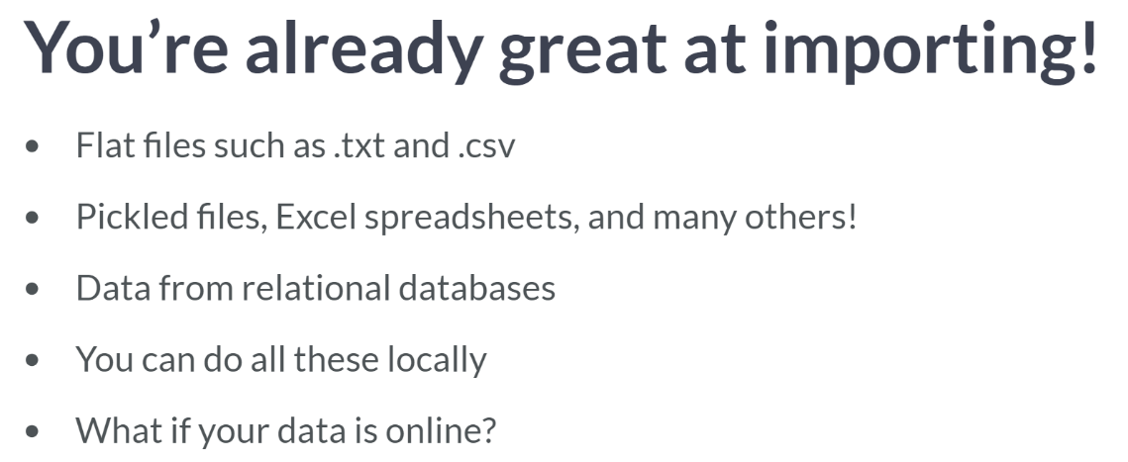

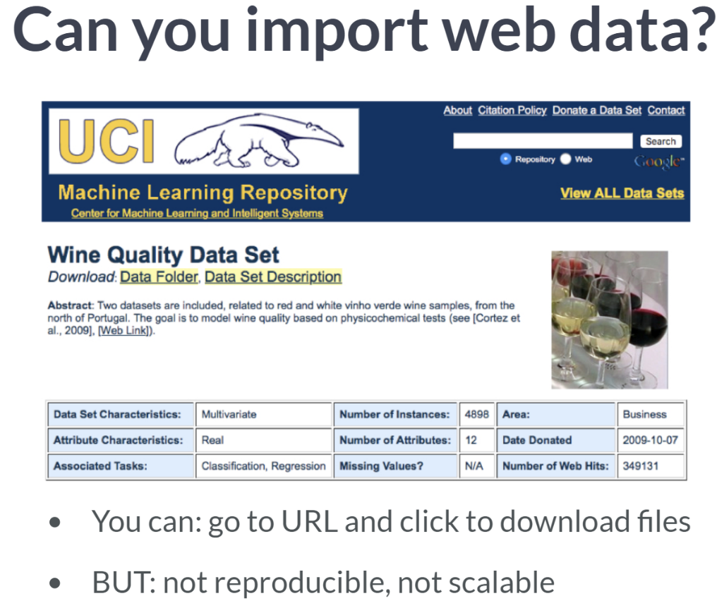  
For example, you want to import the Wine Quality dataset from the Machine Learning Repository hosted by the UC Irvine. How do you get this file from the web?

Now you could use your favorite web browser of choice to navigate to the relevant URL, point and click on the appropriate hyperlinks to download the file, but this poses a few problems.

First, it is not written code and thus poses reproducibility problems. If another Data Scientist wanted to reproduce your workflow, she or he would necessarily have to do so outside Python.

Secondly, it is not scalable. If you wanted to download one hundred or one thousand such files, it would take one hundred or one thousand times as long, whereas if you wrote it in code, it would much be scalable.

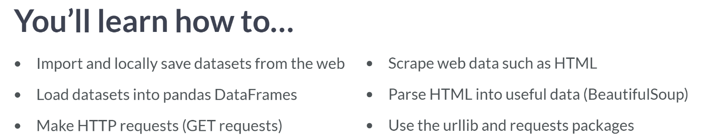  
As reproducibility and scalability are situated at the very heart of Data Science, you are going to learn these things above outlined.

There are a number of great packages to help us import web data: herein, you will become familiar with the *urllib* and *requests* packages. We will first check out *urllib*.

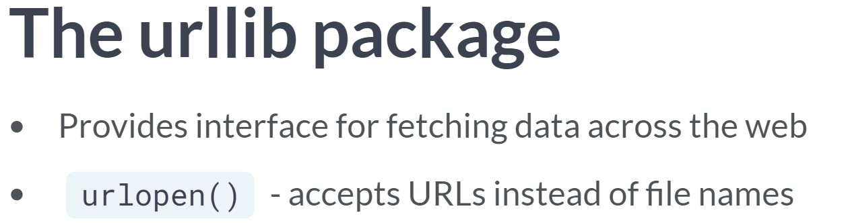

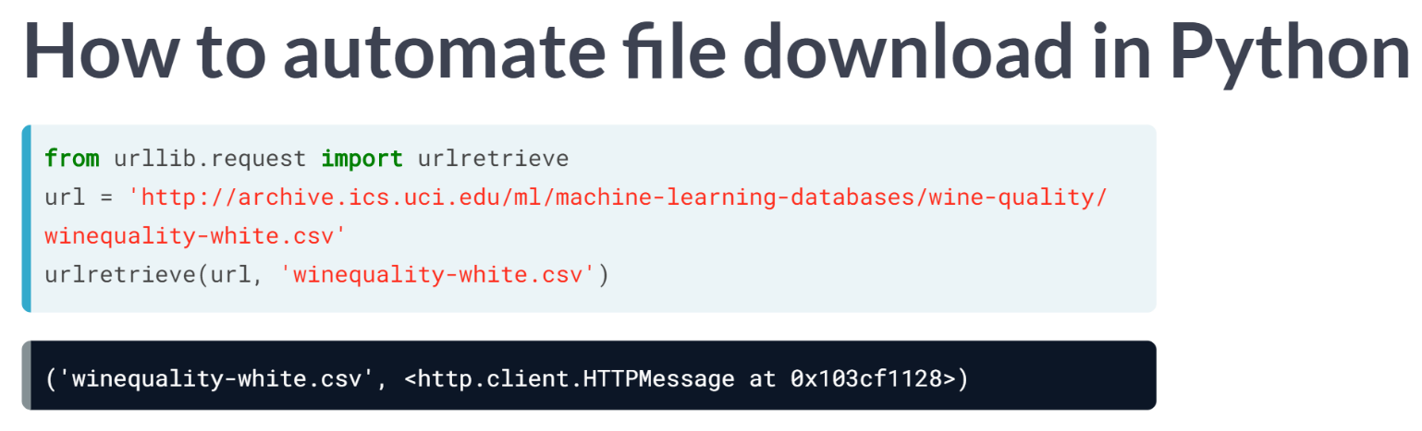  
All we have done here is imported a function called ***urlretrieve()*** from the request subpackage of the urllib package, we assigned the relevant URL as a string to the variable url.

We then used the ***urlretrieve()*** function to write the contents of the *url* to a file *'wineqlity-white.csv'*.

# Importing flat files from the web: your turn!

You are about to import your first file from the web! The flat file you will import will be 'winequality-red.csv' from the University of California, Irvine's [**Machine Learning repository**](http://archive.ics.uci.edu/ml/index.html). The flat file contains tabular data of physiochemical properties of red wine, such as pH, alcohol content and citric acid content, along with wine quality rating.

The URL of the file is

'https://s3.amazonaws.com/assets.datacamp.com/production/course_1606/datasets/winequality-red.csv'

After you import it, you'll check your working directory to confirm that it is there and then you'll load it into a pandas DataFrame.

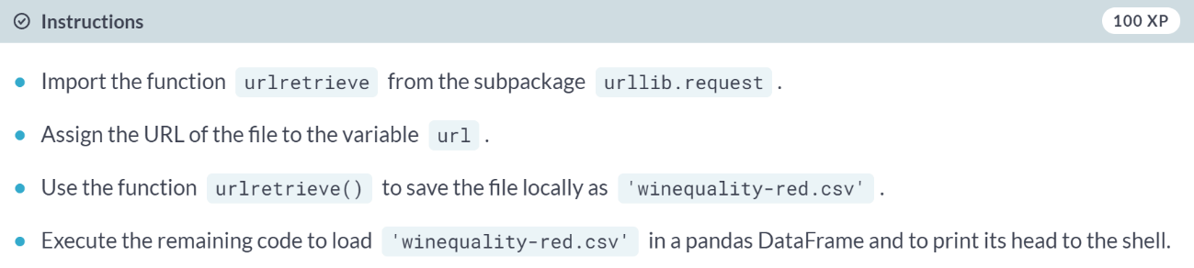

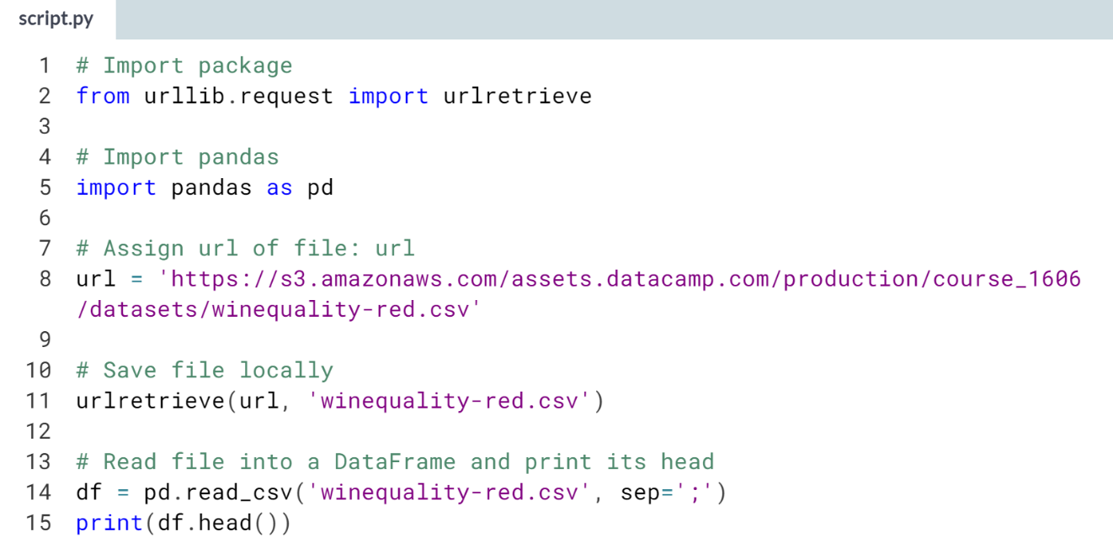  
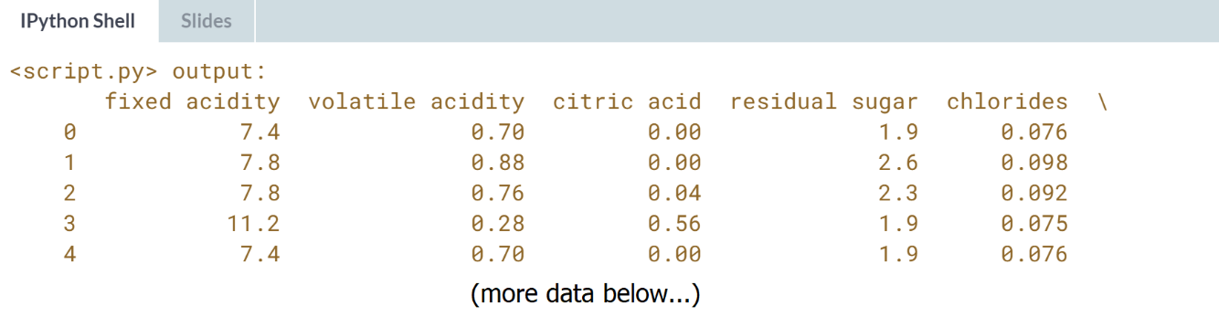

# Opening and reading flat files from the web

You have just imported a file from the web, saved it locally and loaded it into a DataFrame. If you just wanted to load a file from the web into a DataFrame without first saving it locally, you can do that easily using pandas.

In particular, you can use the function pd.read_csv() with the URL as the first argument and the separator sep as the second argument.

The URL of the file, once again, is

'https://s3.amazonaws.com/assets.datacamp.com/production/course_1606/datasets/winequality-red.csv'

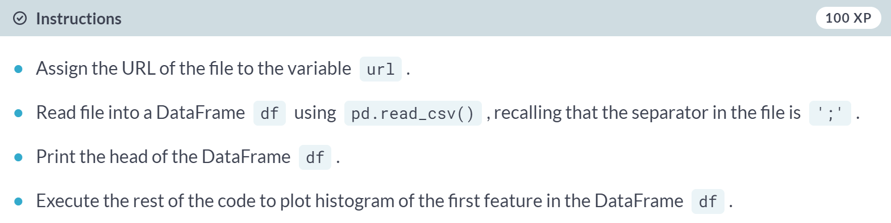

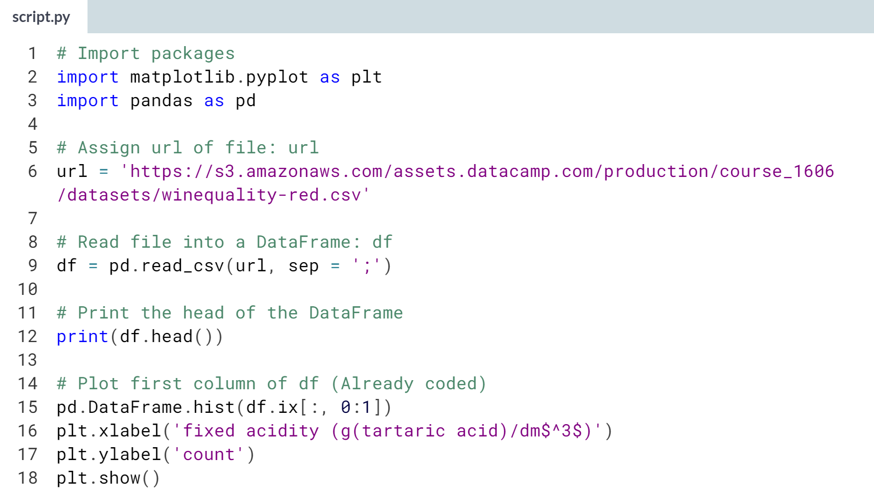

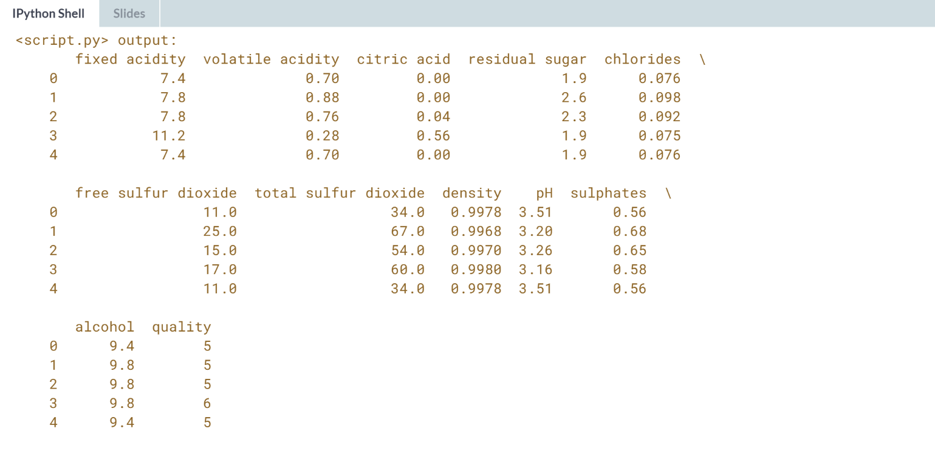  
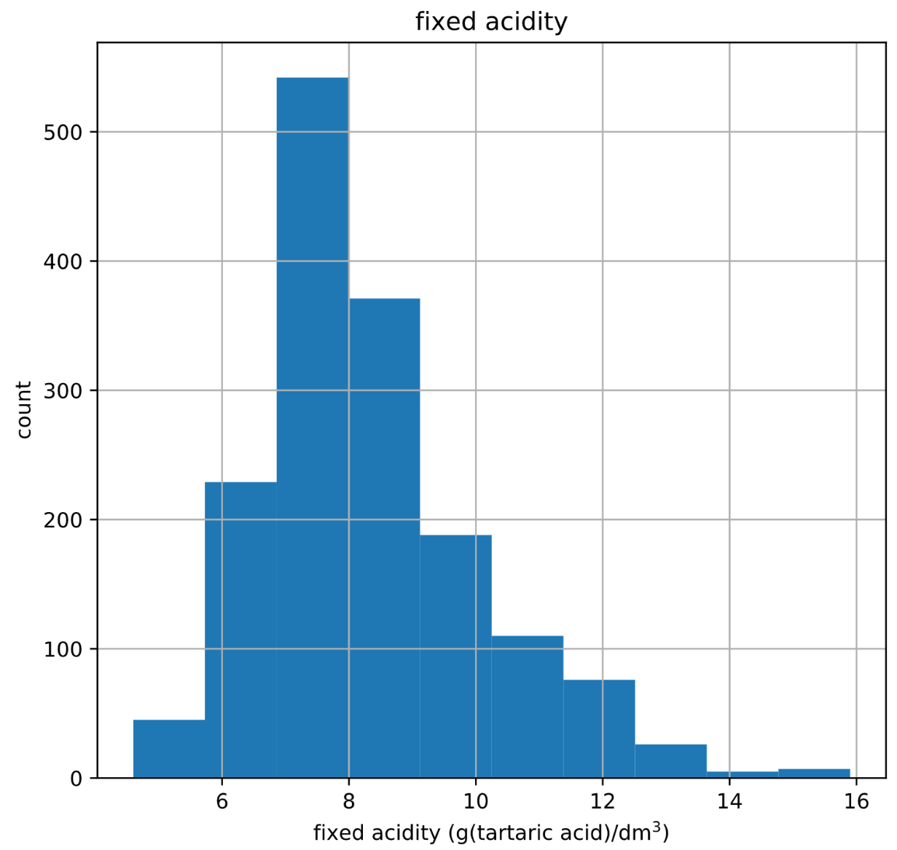

# Importing non-flat files from the web

Congrats! You've just loaded a flat file from the web into a DataFrame without first saving it locally using the pandas function pd.read_csv(). This function is super cool because it has close relatives that allow you to load all types of files, not only flat ones. In this interactive exercise, you'll use pd.read_excel() to import an Excel spreadsheet.

The URL of the spreadsheet is

'http://s3.amazonaws.com/assets.datacamp.com/course/importing_data_into_r/latitude.xls'

Your job is to use pd.read_excel() to read in all of its sheets, print the sheet names and then print the head of the first sheet using its name, not its index.

Note that the output of pd.read_excel() is a Python dictionary with sheet names as keys and corresponding DataFrames as corresponding values.

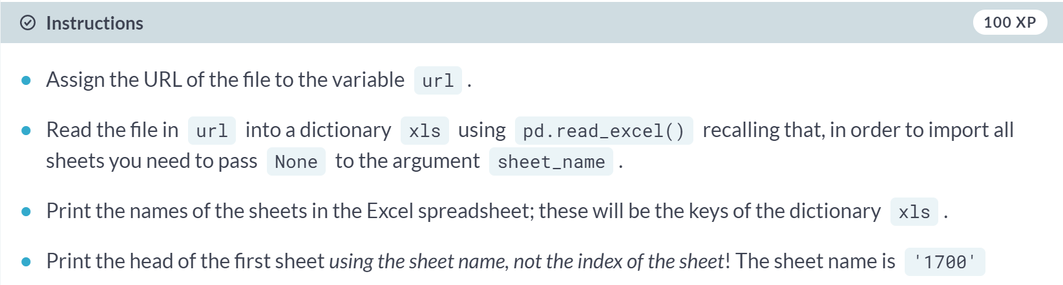  
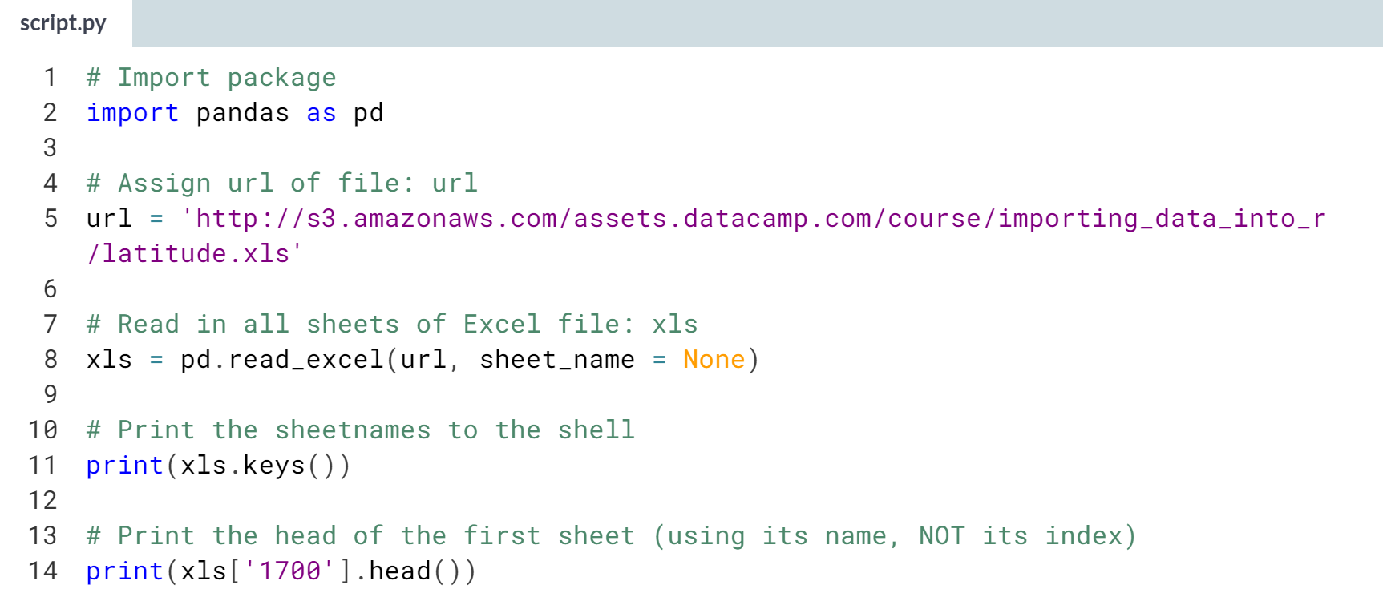

(Result on the next page)

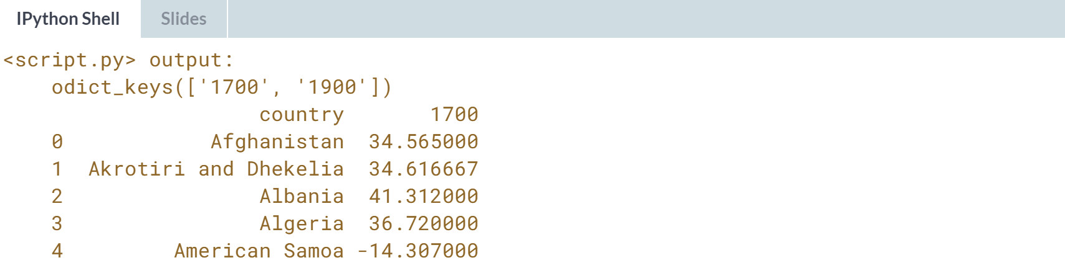



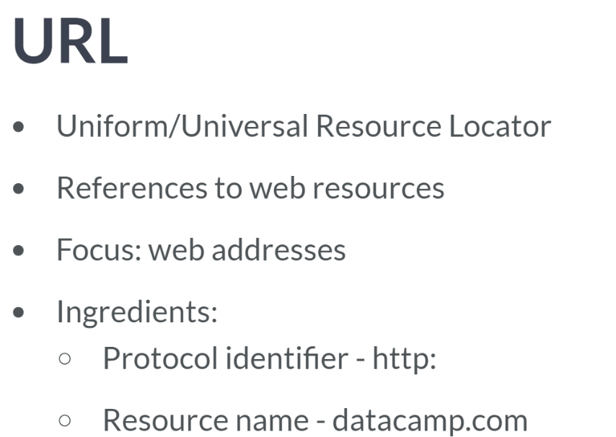  
The vast majority of URLs are web addresses, but they can refer to a few other things, such as file transfer protocols (FTP) and database access.

Such a URL consists of 2 parts, a protocol identifier http or https and a resource name such as datacamp.com.

The combination of protocol identifier and resource name uniquely specifies the web address. To explain URLs, I have introduced yet another acronym http.

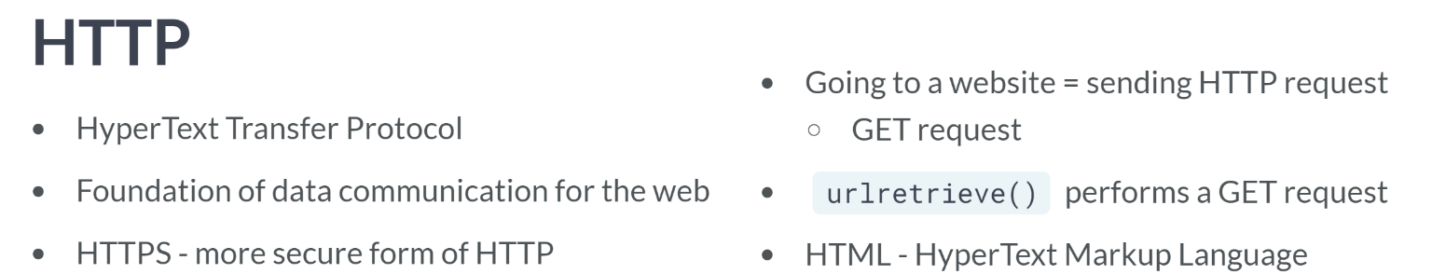

Each time you go to a website, you are actually sending an HTTP request to a server. This request is known as a GET request, by far the most common type of HTTP request. We are actually performing a GET request when using the function urlretrieve.

The ingenuity of urlretrieve also lies in fact that it not only makes a GET request but also saves the relevant data locally. In the following, we will learn how to make more GET request to store web data in your environment.

In particular, we will figure out how to get the HTML data from a webpage. HTML stands for Hypertext Markup Language and is the standard markup language for the web.

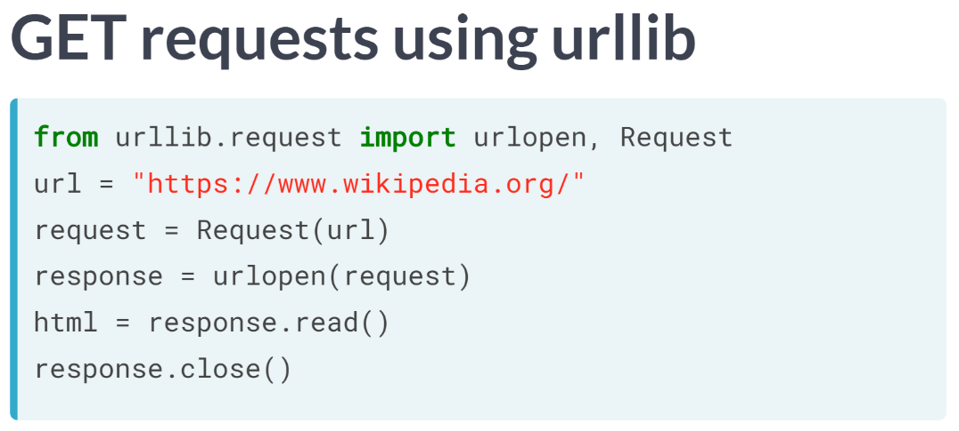  
To extract the html from the Wikipedia home page, you import the necessary functions, specify the URL, package the GET request using the function ***Request()***, send the request and catch the response using the function ***urlopen()***.

This returns an HTTPResponse object, which has an associated ***read()***method. You then apply this ***read()*** response to the response, which returns the HTML as a string, which you store in the variable html. Finally, you remember to be polite and close the response.

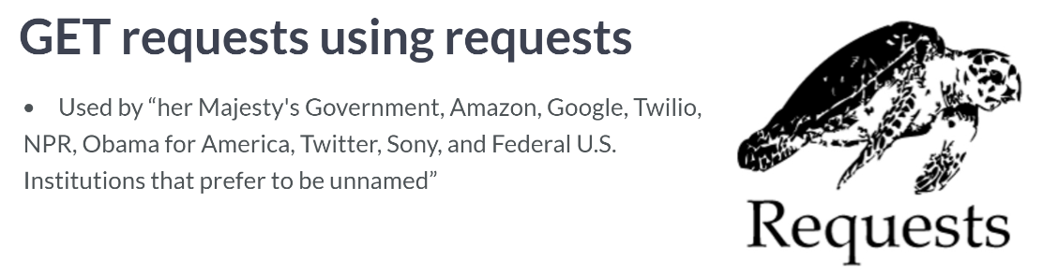  
Now we are going to do the same; however, we will use the request package, which provides a wonderful API for making request.

According to the requests package website, "Requests allows you to send organic, grass-fed HTTP/1.1 requests, without the need for manual labor." and the following organizations claim to use request internally.

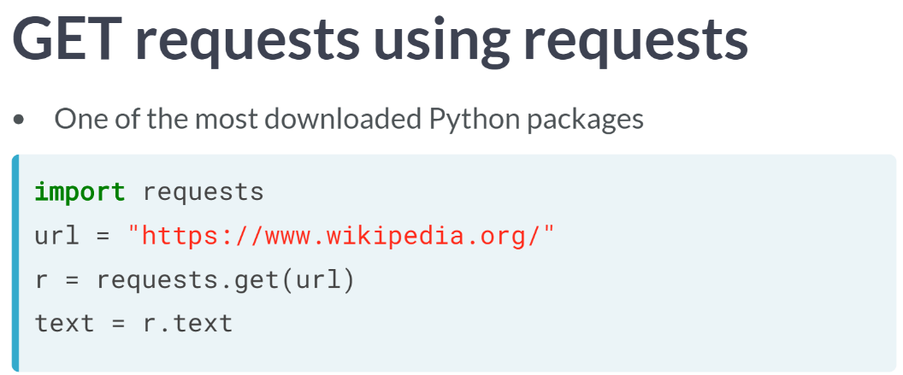  
Here, you import the package requests, specify the URL, package the request, send the request, and catch the response with a single function ***requests.get()***; apply the text method to the response which returns the HTML as a string.

# Performing HTTP requests in Python using urllib

Now that you know the basics behind HTTP GET requests, it's time to perform some of your own. In this interactive exercise, you will ping our very own DataCamp servers to perform a GET request to extract information from our teach page, "http://www.datacamp.com/teach/documentation".

In the next exercise, you'll extract the HTML itself. Right now, however, you are going to package and send the request and then catch the response.

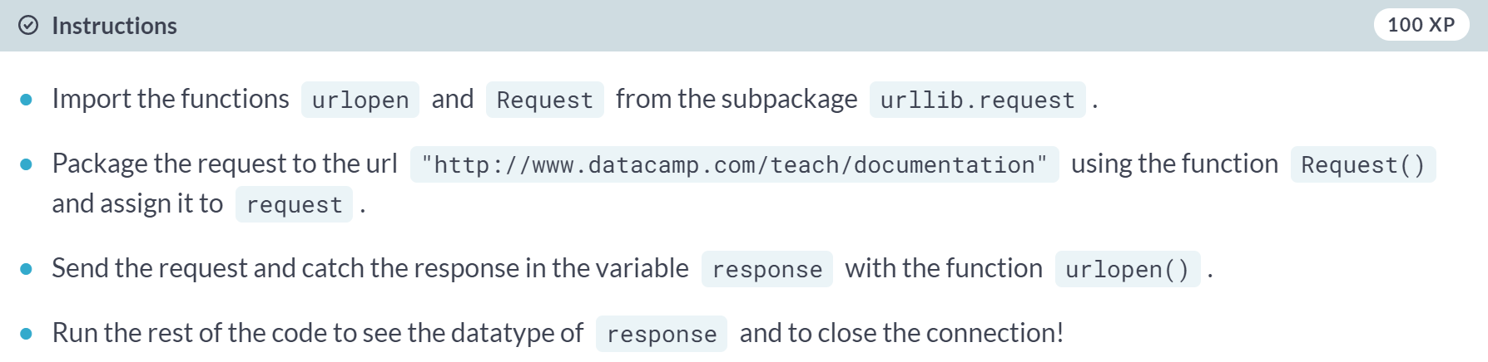

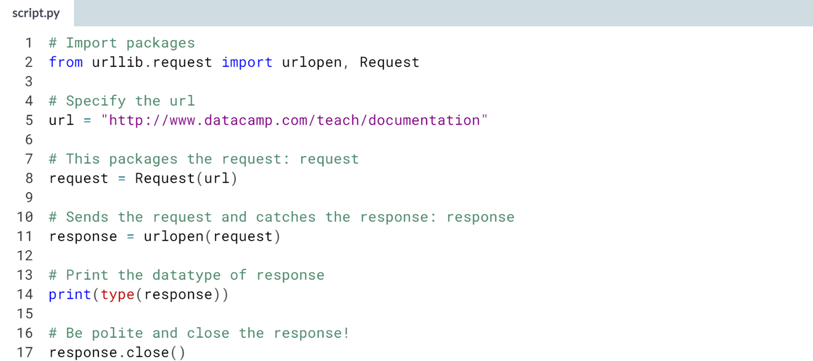  
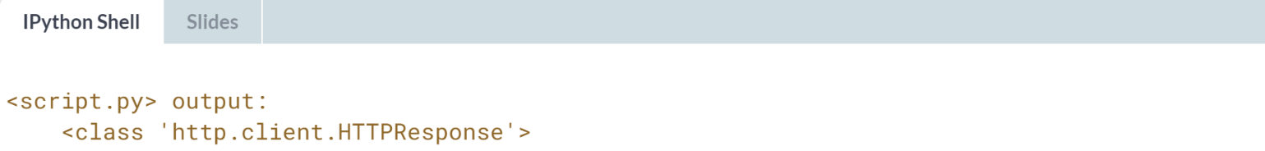

# Printing HTTP request results in Python using urllib

You have just packaged and sent a GET request to "http://www.datacamp.com/teach/documentation" and then caught the response. You saw that such a response is a http.client.HTTPResponse object. The question remains: what can you do with this response?

Well, as it came from an HTML page, you could read it to extract the HTML and, in fact, such a http.client.HTTPResponse object has an associated read() method. In this exercise, you'll build on your previous great work to extract the response and print the HTML.

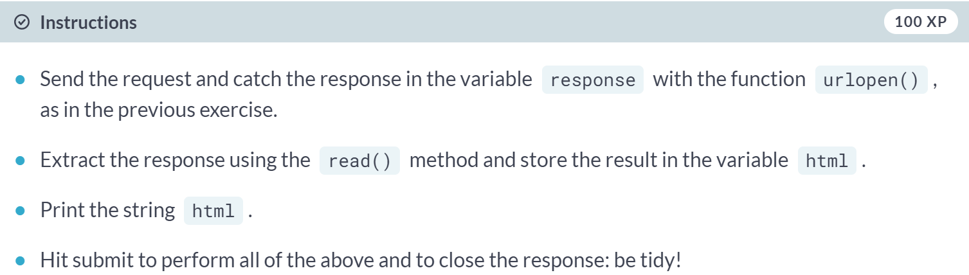

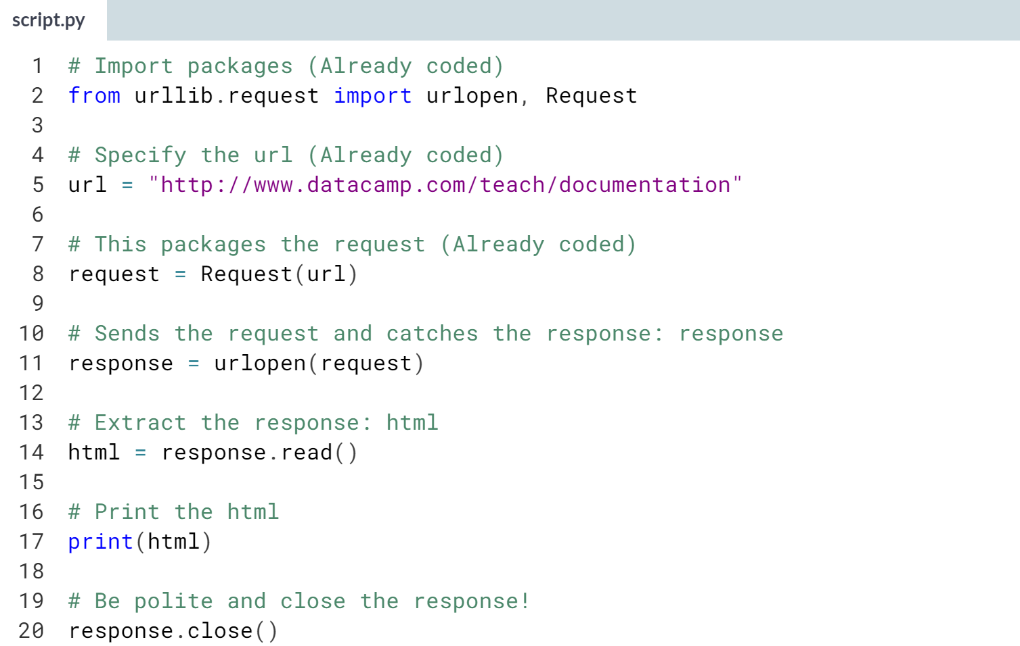  
(Results not shown)

# Performing HTTP requests in Python using requests

Now that you've got your head and hands around making HTTP requests using the urllib package, you're going to figure out how to do the same using the higher-level requests library. You'll once again be pinging DataCamp servers for their "http://www.datacamp.com/teach/documentation" page.

Note that unlike in the previous exercises using urllib, you don't have to close the connection when using requests!

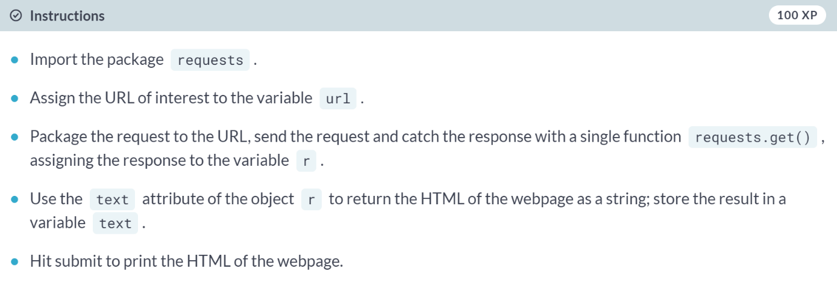

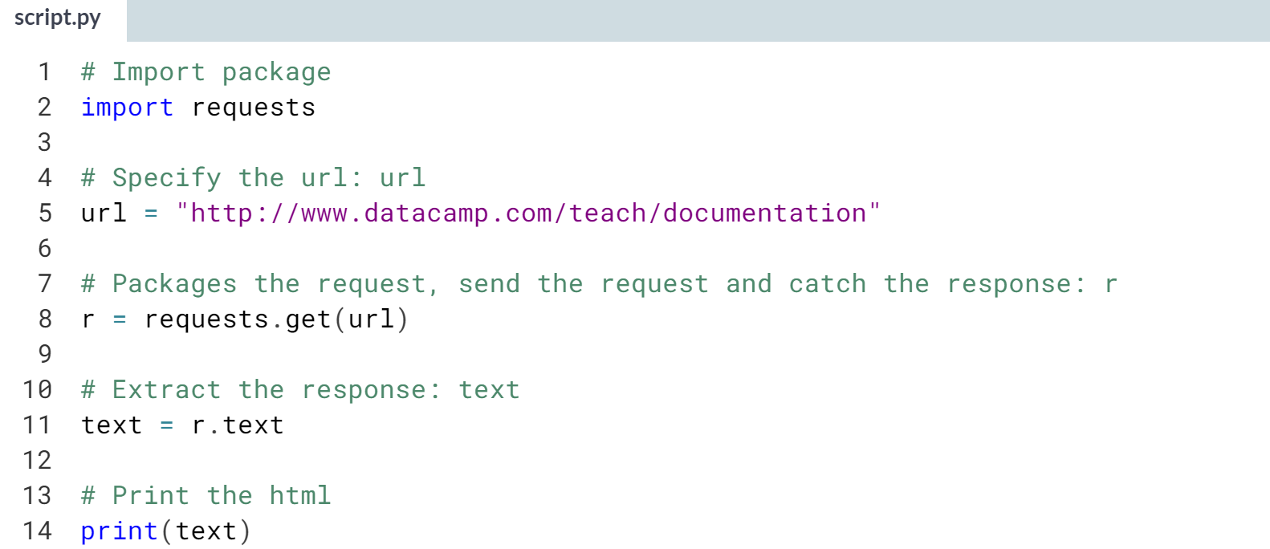  
  
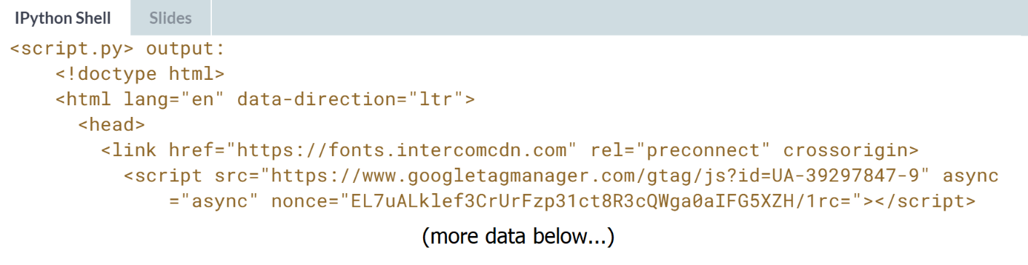



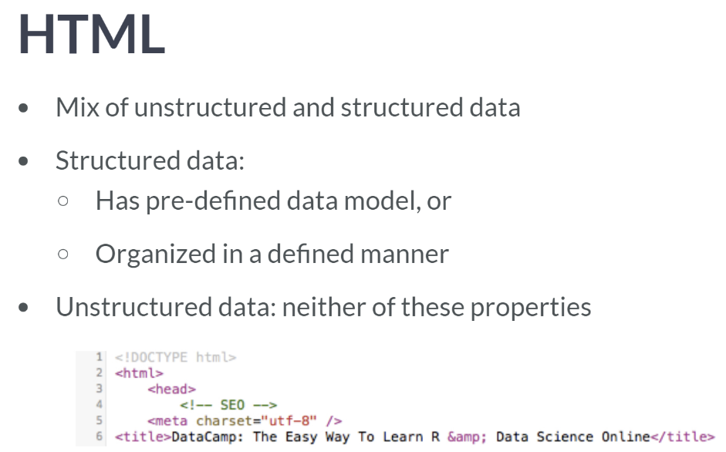  
HTML is interesting because, although much of it is unstructured text, it does contain tags that determine where, for example, headings can be found and hyperlinks.

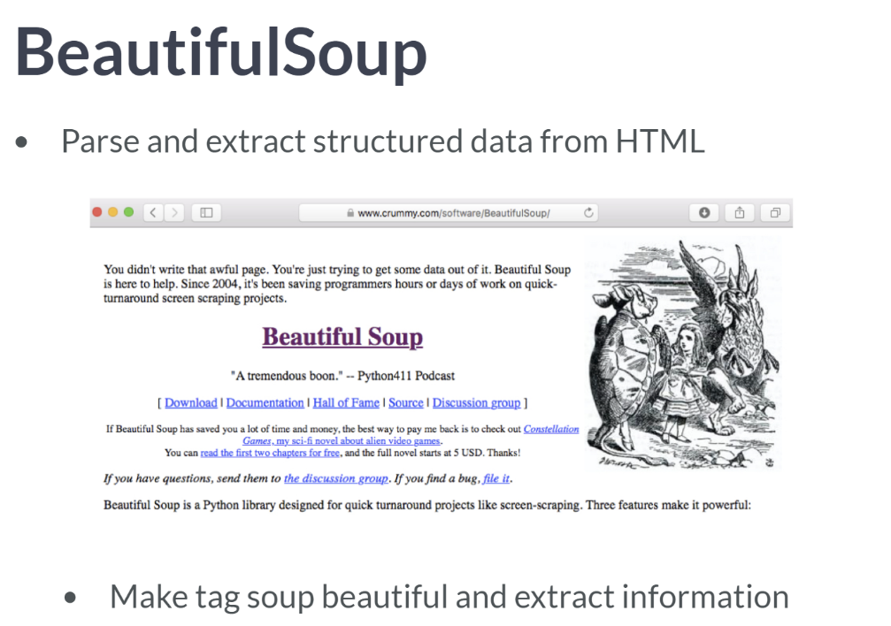  
In general, to turn HTML that you have scraped from the world wide web into useful data, you'll need to parse it and extract structured data from it. In this video and the next few interactive exercises, we will provide a brief introduction as to how you can perform such tasks using the Python package BeautifulSoup. Let's check out the website. The first few sentences at the top are: *"you didn't write that awful page. You're just trying to get some data out of it. Beautiful Soup is here to help...so on."*

Firstly, a word on the name of the package: BeautifulSoup? In web development, the term *"tag soup"* refers to structurally or syntactically incorrect HTML code written for a web page. What beautiful soup does best is to make tag soup beautiful again and to extract information from it with ease. In fact, the main object created and queried when using this package is called BeautifulSoup, and it has a very important associated method called *prettify*.

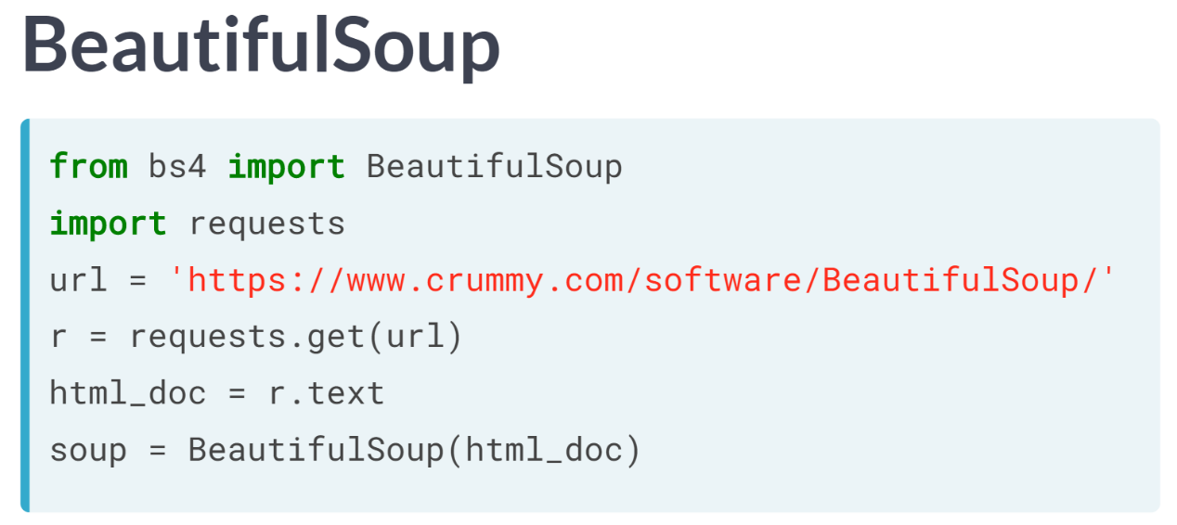  
Once again, we use request to scrape the HTML from the web. Then, you create a BeautifulSoup object from the resulting HTML and prettify.

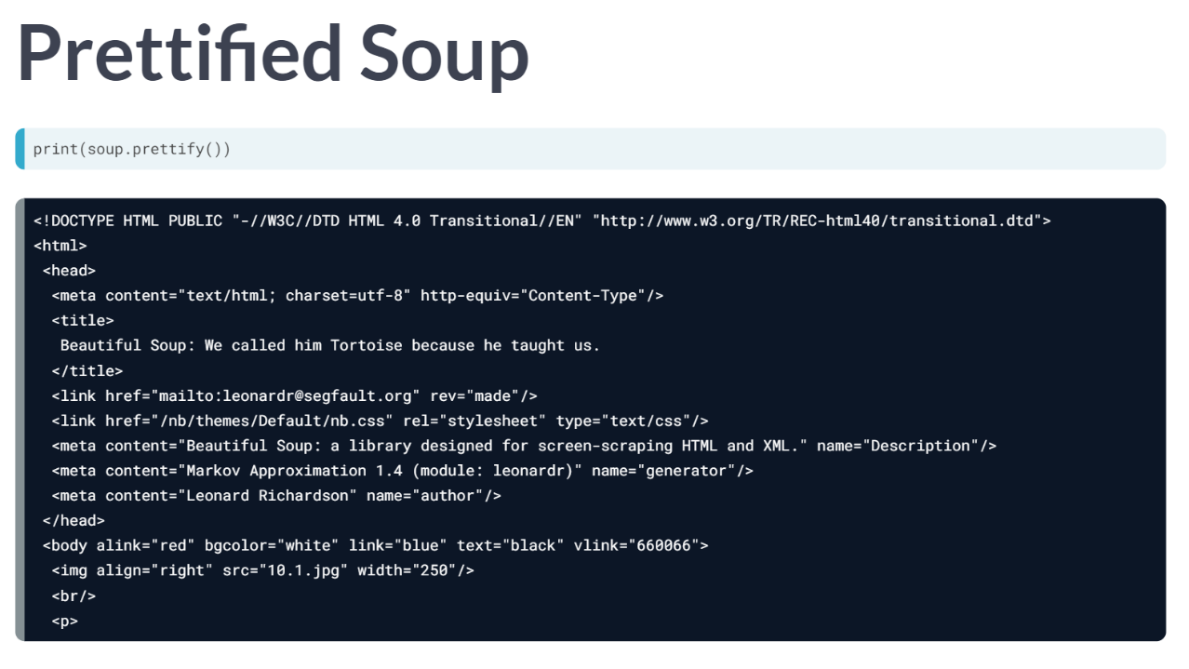  
Printing the prettified Soup and the original HTML, you can see that the prettified Soup is indented in the way you would expect properly written HTML to be.

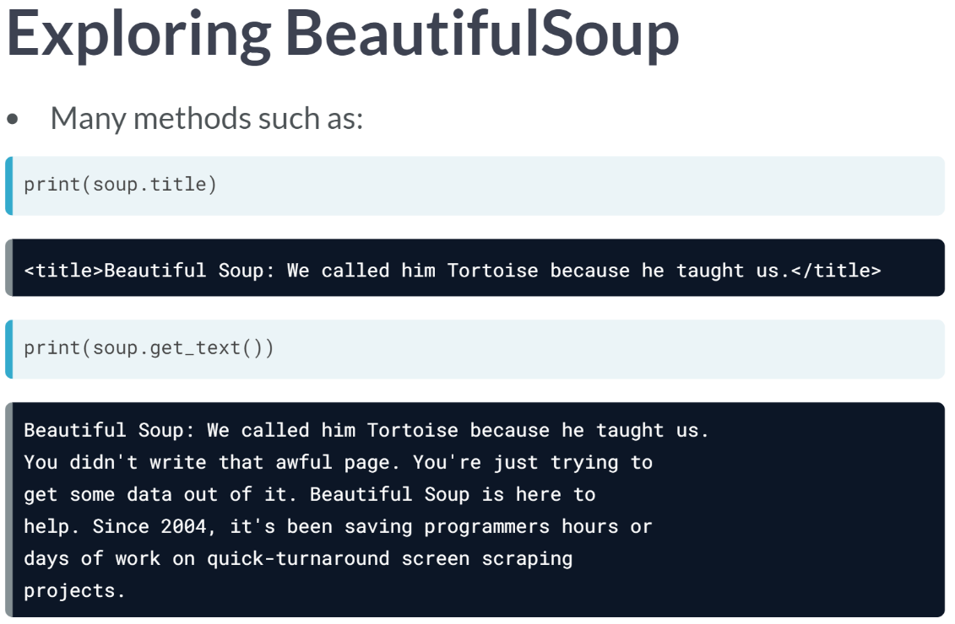  
You will explore a few of the methods that you can apply to your soupified HTML in the following exercises, such as ***title*** and ***get_text()***, which extract the title and text, respectively.

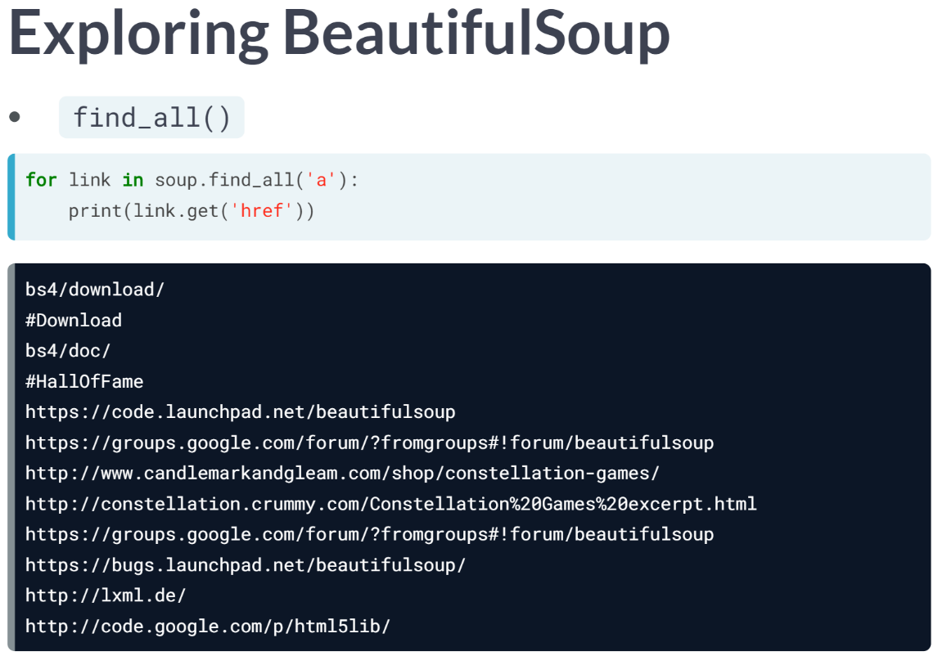  
You will also work with the Soupy method ***find_all()*** to extract the URLs of all of the hyperlinked in the HTML. These are merely a few of many methods existing in BeautifulSoup to extract data from HTML. If you still find yourself thirsting for more beautiful soup, there are plenty of great resources on their website.

# Parsing HTML with BeautifulSoup

In this interactive exercise, you'll learn how to use the BeautifulSoup package to parse, prettify and extract information from HTML. You'll scrape the data from the webpage of Guido van Rossum, Python's very own [**Benevolent Dictator for Life**](https://en.wikipedia.org/wiki/Benevolent_dictator_for_life). In the following exercises, you'll prettify the HTML and then extract the text and the hyperlinks.

The URL of interest is url = 'https://www.python.org/~guido/'.

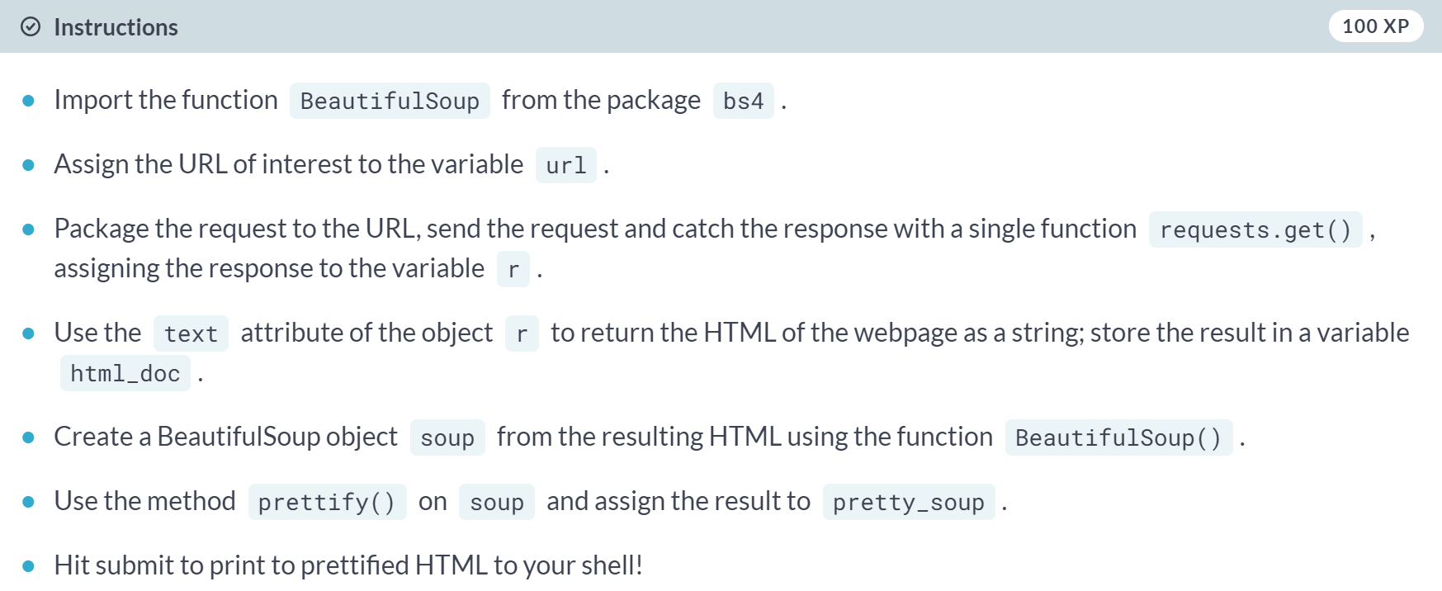  
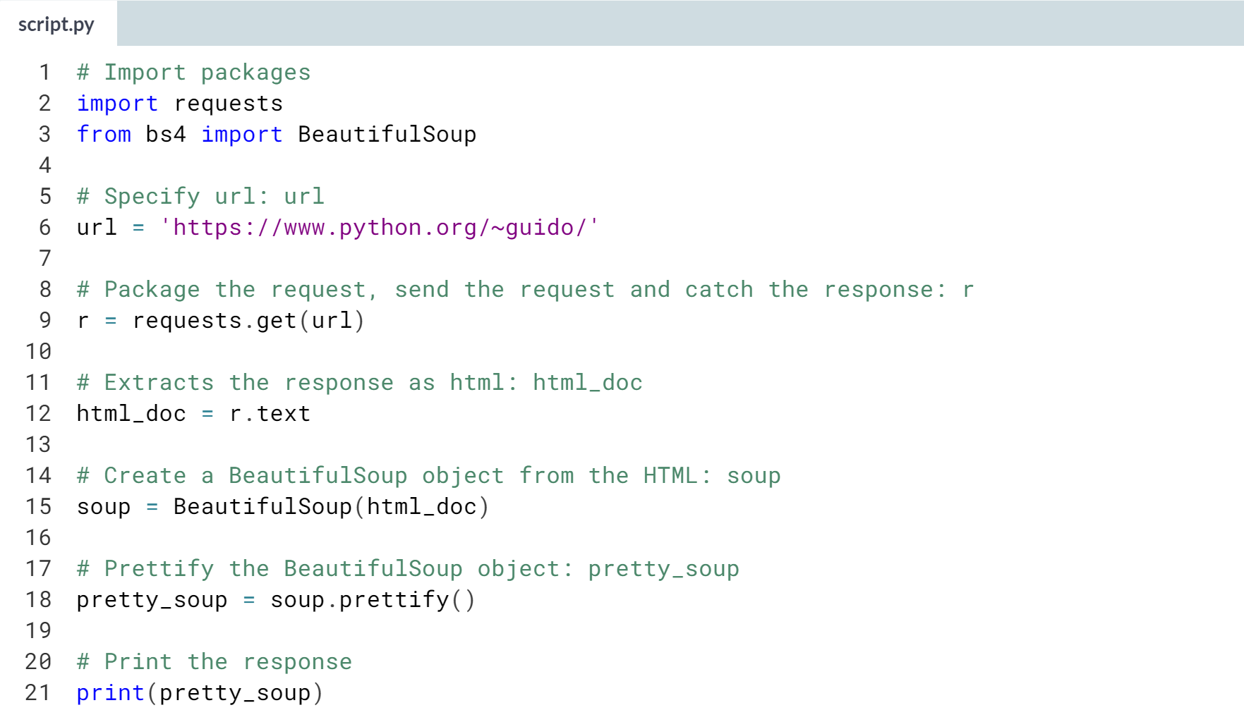

# Turning a webpage into data using BeautifulSoup: getting the text

As promised, in the following exercises, you'll learn the basics of extracting information from HTML soup. In this exercise, you'll figure out how to extract the text from the BDFL's webpage, along with printing the webpage's title.

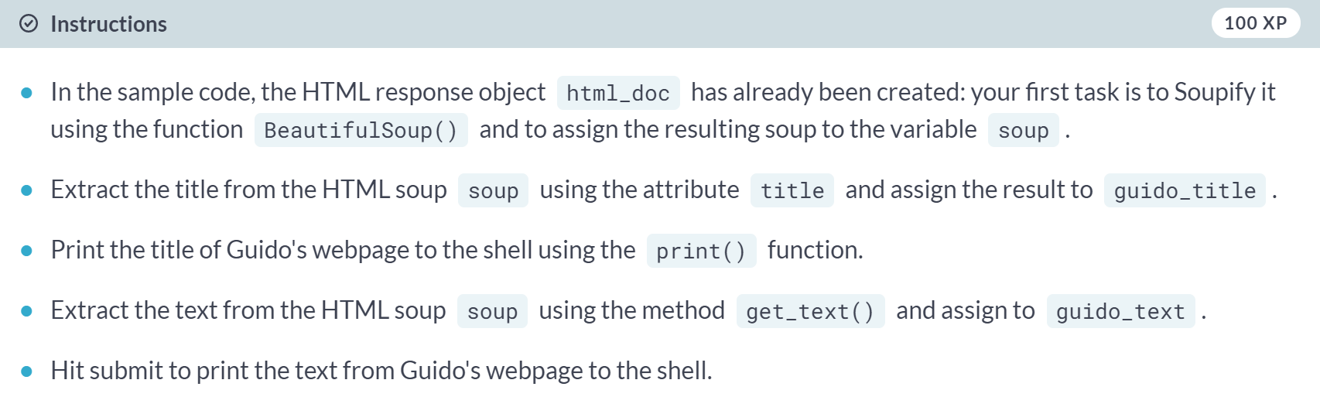  
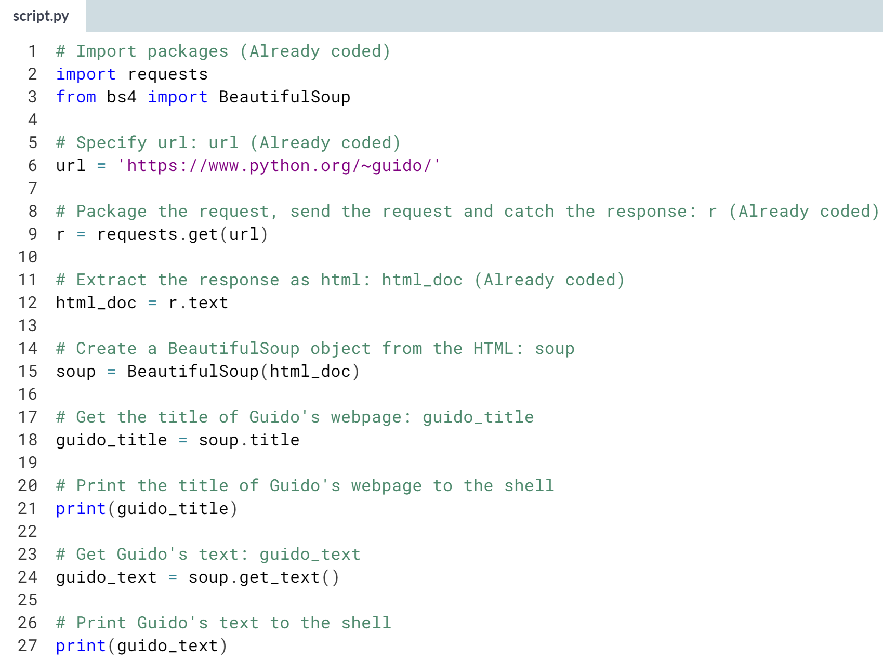

# Turning a webpage into data using BeautifulSoup: getting the hyperlinks

In this exercise, you'll figure out how to extract the URLs of the hyperlinks from the BDFL's webpage. In the process, you'll become close friends with the soup method find_all().

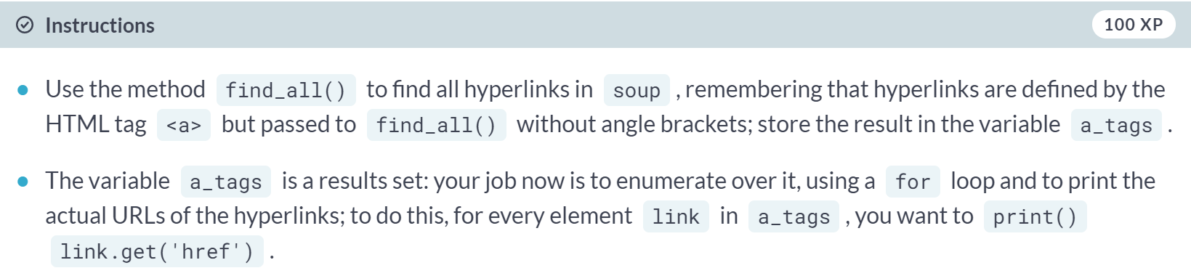  
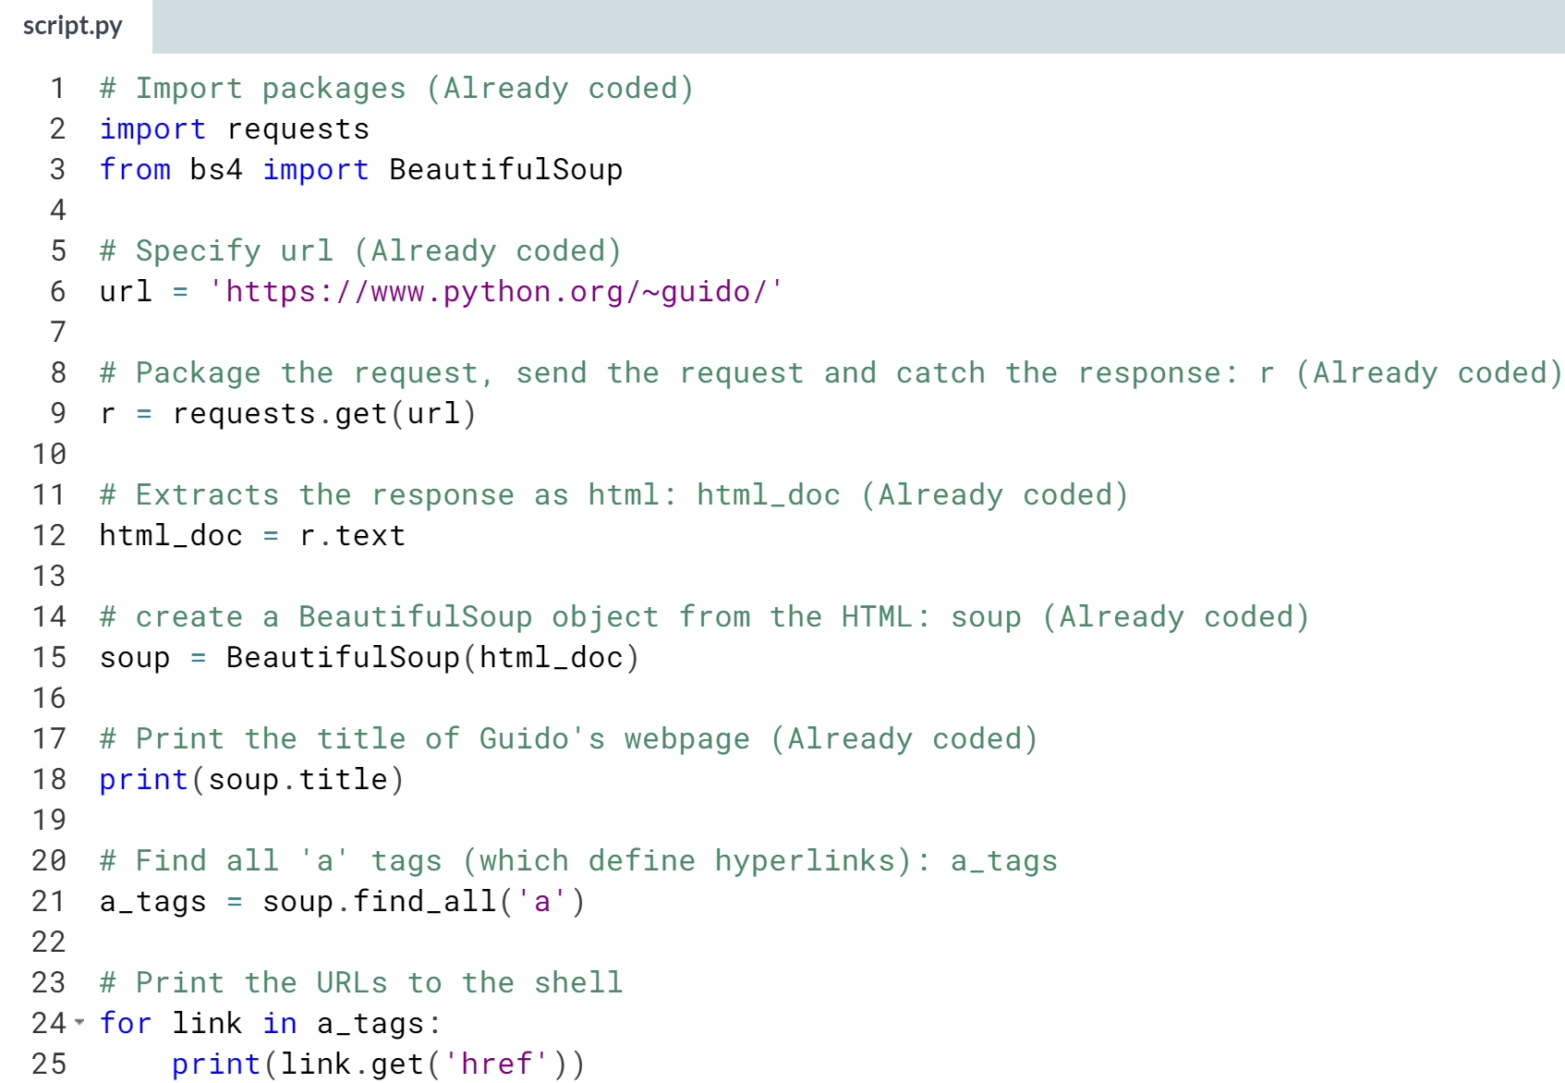  
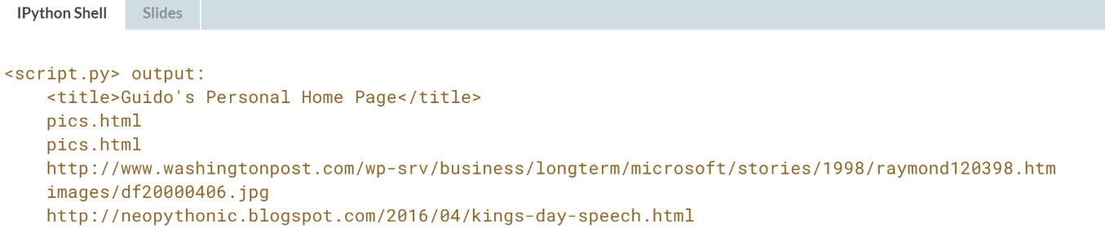

**2. Interacting with APIs to import data from the web**

In this chapter, you will gain a deeper understanding of how to import data from the web. You will learn the basics of extracting data from APIs, gain insight on the importance of APIs, and practice extracting data by diving into the OMDB and Library of Congress APIs.



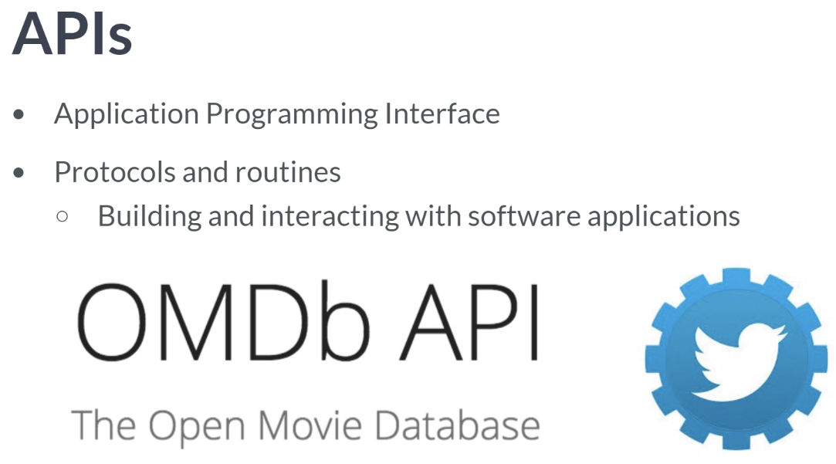  
In this chapter, we will learn how to use the Open Movie Database API and twitter API to pull data from both applications, while learning about API interaction best practices. A standard form for transferring data through API is the JSON file format.

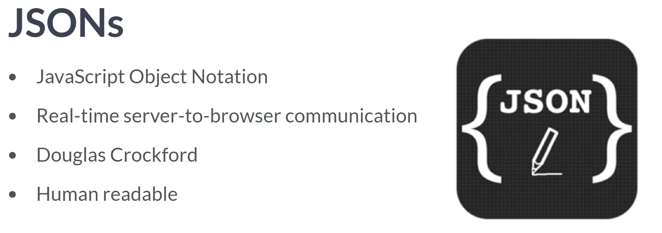  
JSONs are naturally be read by human unlike pickle files as we saw in the previous course.

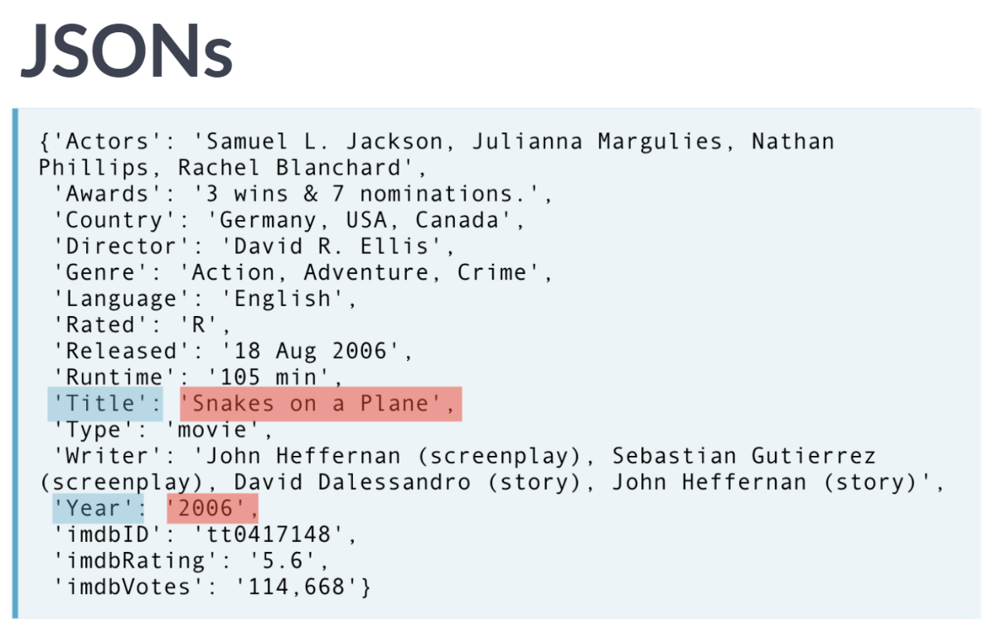  
Here you see a JSON from the OMDB OR Open Movie Database API. In particular, this is JSON containing information about the movie Snakes on a Plane.

First, notice that the JSON consists of name-value pairs separated by commas. This will remind you of the key-value pairs in a Python dictionary. We will see in a minute that, for this reason, while loading JSON into Python, it is natural to store them in a dict.

The keys in JSONs will always be strings enclosed in quotation marks. The values can be strings, integers, arrays, or even objects. Such an object can even be a JSON, and then you have nested JSONs. We can see that all the values are strings and we can see this from the quotation marks.

The value corresponding to the key 'Title' is the tile of the movie as a string: 'Snakes on a Plane'. We will soon learn how to use the OMDB API and Python to automate retrieval of such data, but first you'll figure out how to load JSONs from a local directory.

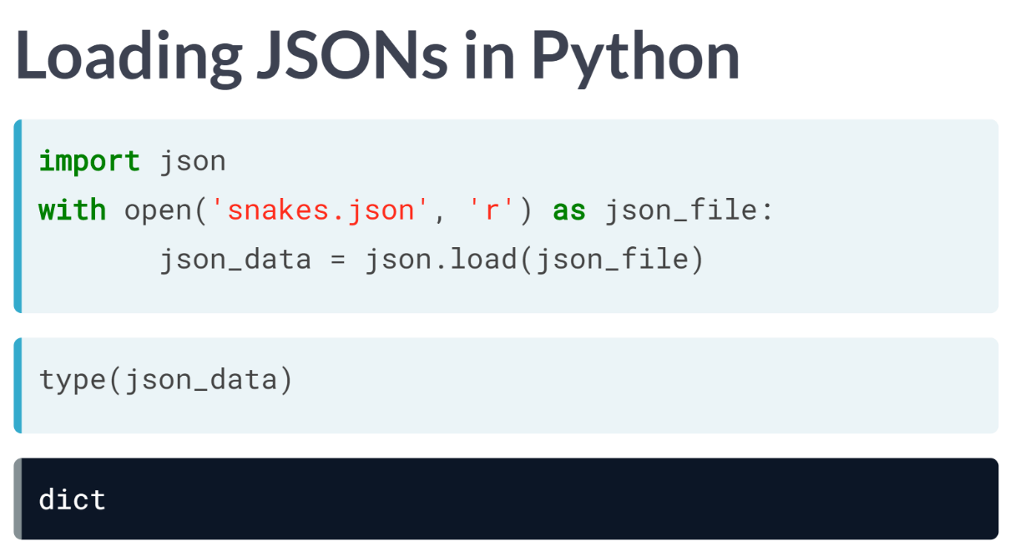  
Let's say that I had the JSON stored in my working directory as *'snakes.json'*.

To load the JSON into my Python environment, I would first import the package json and then open a connection to the file and use the function ***json.load()*** to load the JSON.

When checking the datatype, it comes out to be one of dict type, indicating Python cleverly imported the JSON as a dictionary.

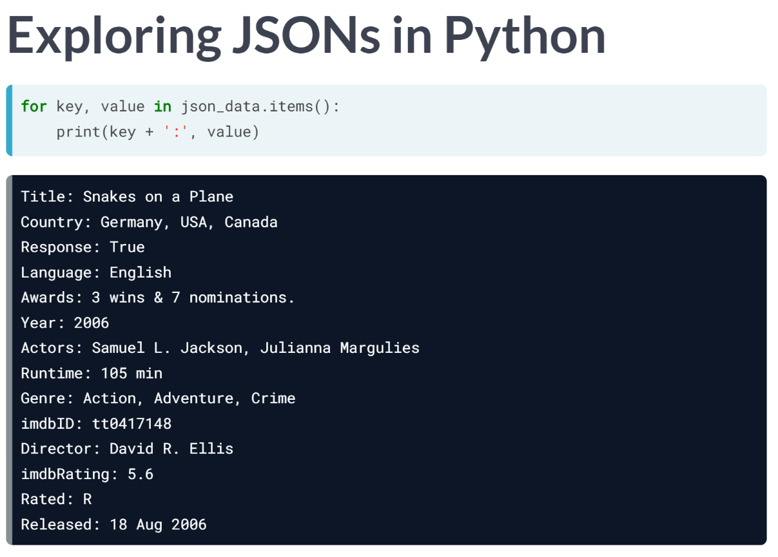  
To print the key-value pairs to the console, I can reiterate over the key-value pairs using a for loop.

# Pop quiz: What exactly is a JSON?

Which of the following is **NOT** true of the JSON file format?

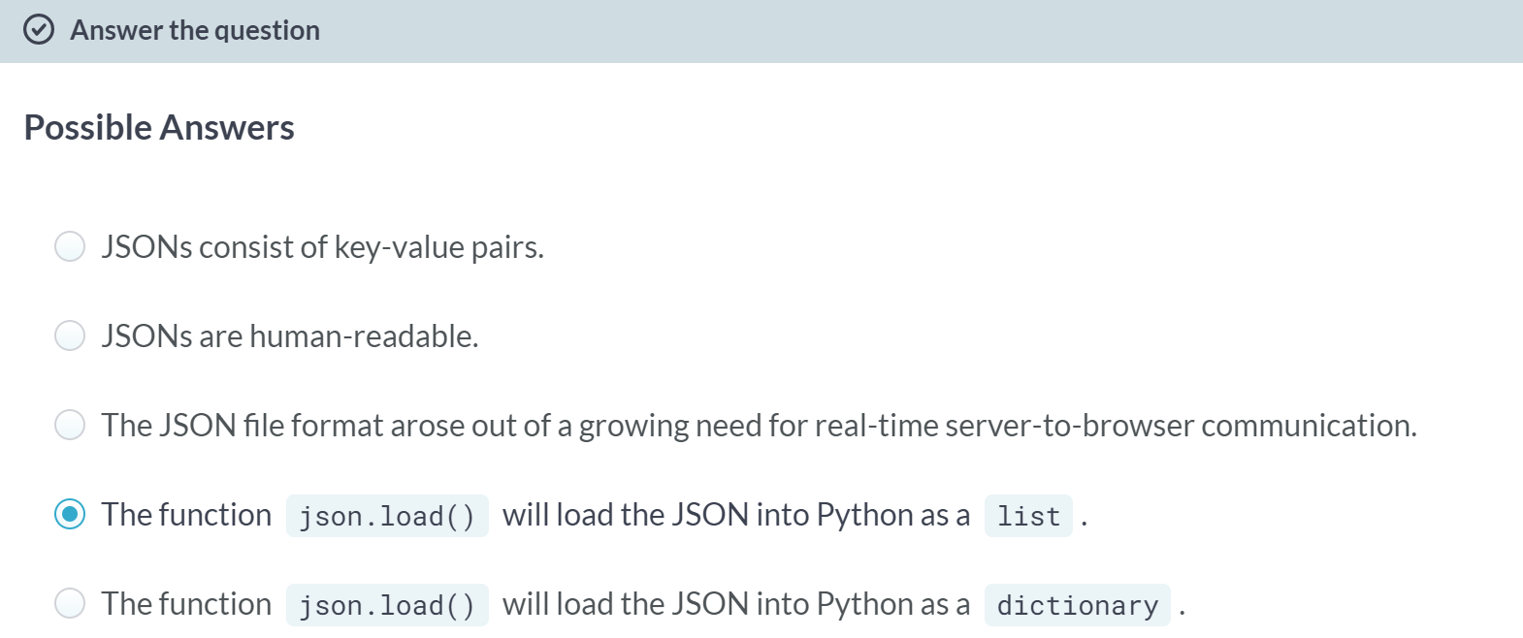

# Loading and exploring a JSON – **REVIEW**

Now that you know what a JSON is, you'll load one into your Python environment and explore it yourself. Here, you'll load the JSON 'a_movie.json' into the variable json_data, which will be a dictionary. You'll then explore the JSON contents by printing the key-value pairs of json_data to the shell.

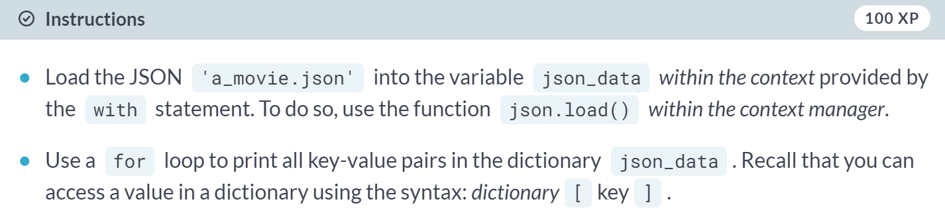

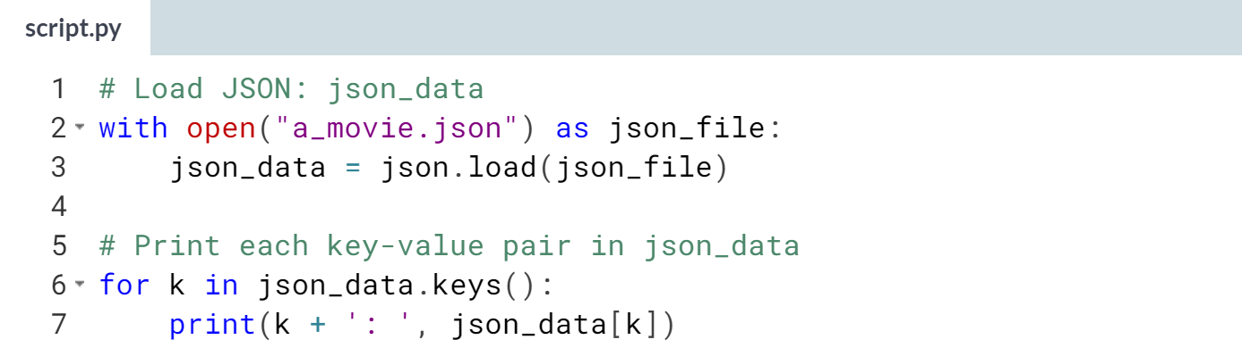  
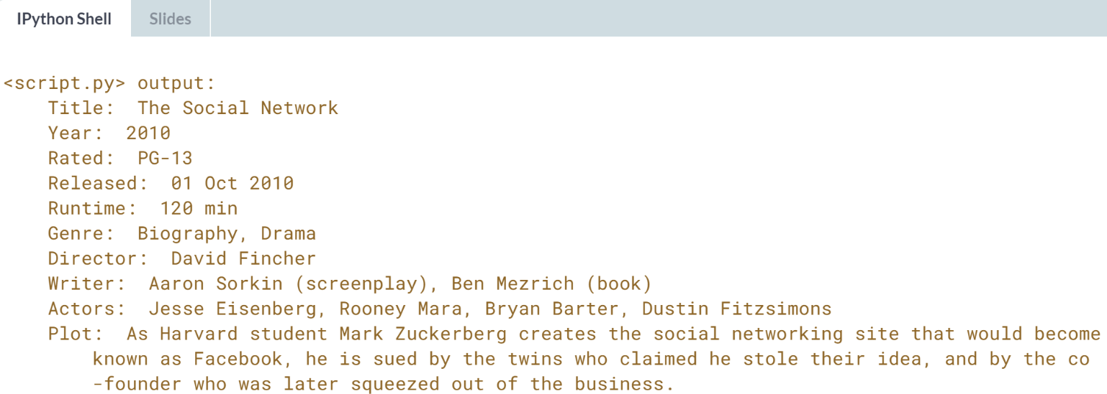

# Pop quiz: Exploring your JSON

Load the JSON 'a_movie.json' into a variable, which will be a dictionary. Do so by copying, pasting and executing the following code in the IPython Shell:

import json

with open("a_movie.json") as json_file:

json_data = json.load(json_file)

Print the values corresponding to the keys 'Title' and 'Year' and answer the following question about the movie that the JSON describes:

Which of the following statements is true of the movie in question?

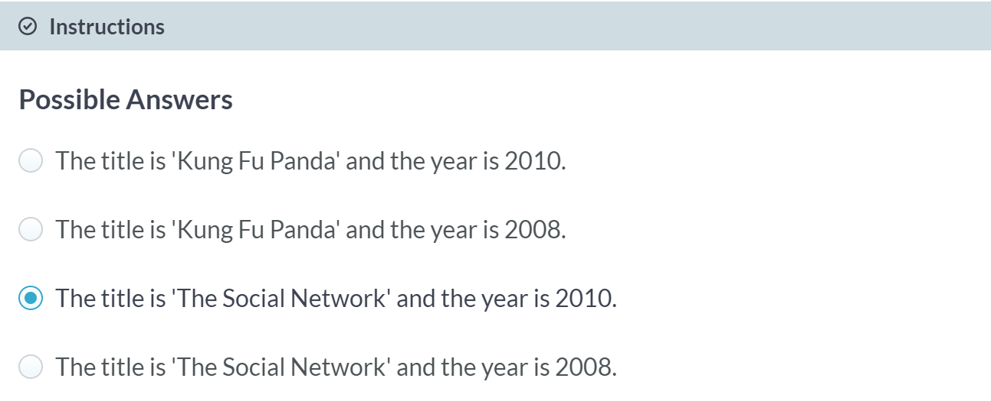



Much of the data that you'll get from APIs are packaged as JSONs.

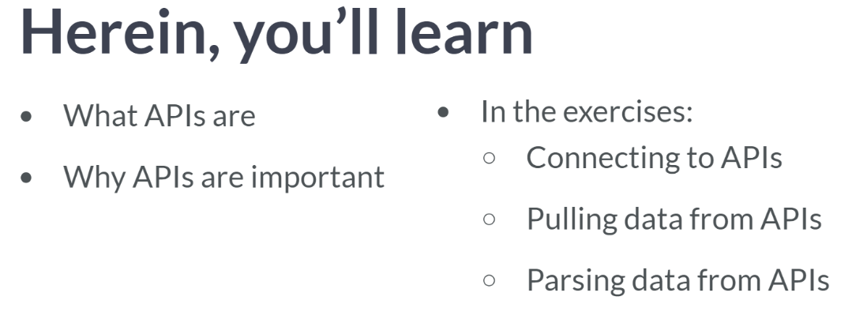

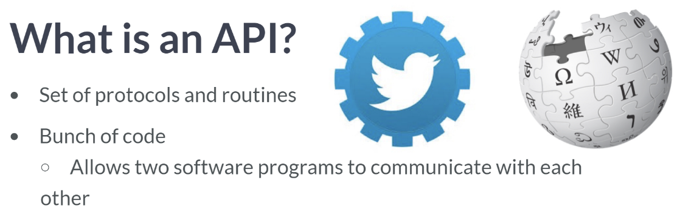  
For example, if you wanted to stream twitter data by writing some Python code, you would use the Twitter API. If you wanted to automate pulling and processing information from Wikipedia, you could do so using the Wikipedia API.

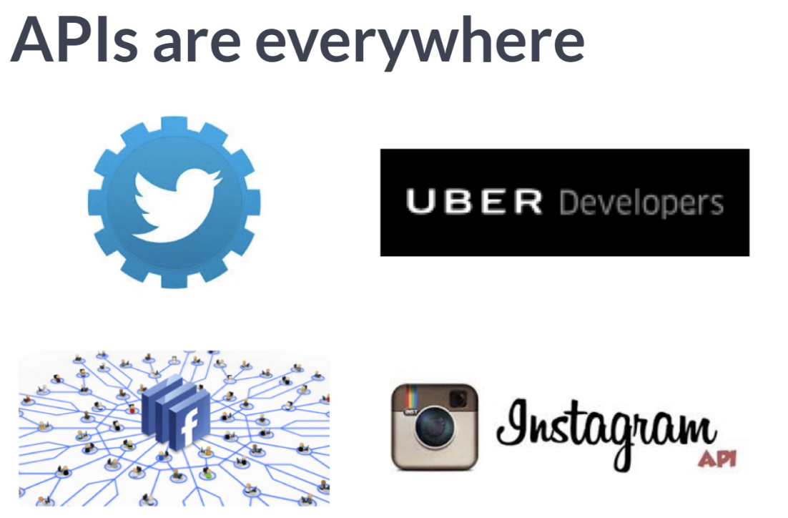  
Using such APIs have now become standard ways of interacting with such applications. Twitter has an API that is used by marketing companies and social scientists engaged in research concerning social networks. Uber, Facebook, Instagram all have APIs. Now let's figure out how to connect to an API and how to pull data from it.

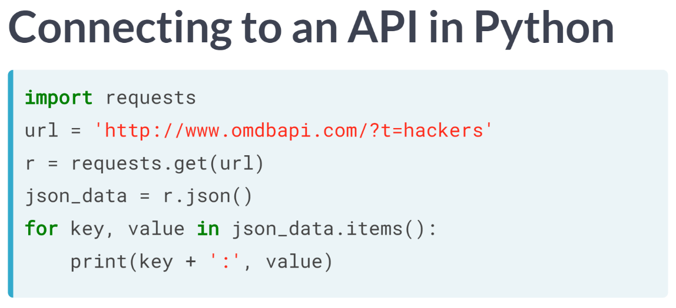

In this example, we will pull movie data from the OMDB, API. You import requests and assign the URL of interest to the variable url. You then package and send the request to the URL, which describes your API query and catch the response in one line of code.

Another really cool aspect of the request package is that the Response objects, such as r, have an associated method json, which is a built-in JSON decoder for when we are dealing with JSON data. This returns a dictionary, and we can then print all the key-value pairs to check out what we pulled from the OMDB API.

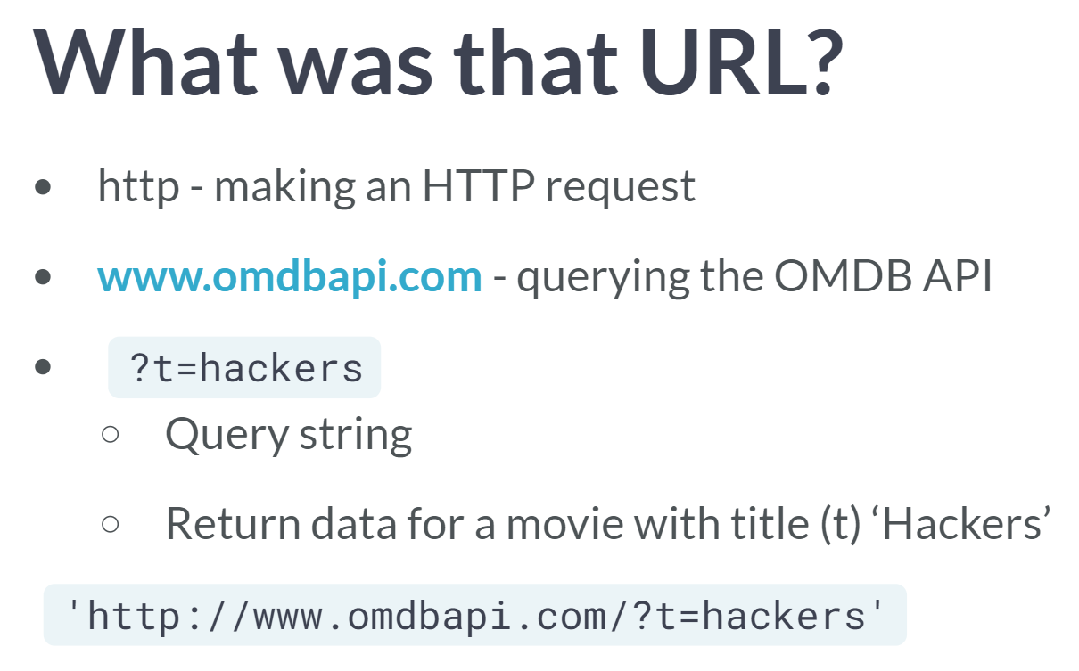  
Now the last thing to discuss is how the URL we used actually pulled data from the API. To do so, let's break it up into chunks. Query Strings are parts of URLs that do not necessarily fit into conventional hierarchical path structure.

What follows the question mark in the query string is the query we are making to the OMBD API. The query we just made was simple: querying *'t=hackers'* asked the API to return the data about the movie with the title Hackers. The *'t'* in the query stood for title.

# Pop quiz: What's an API?

Which of the following statements about APIs is NOT true?

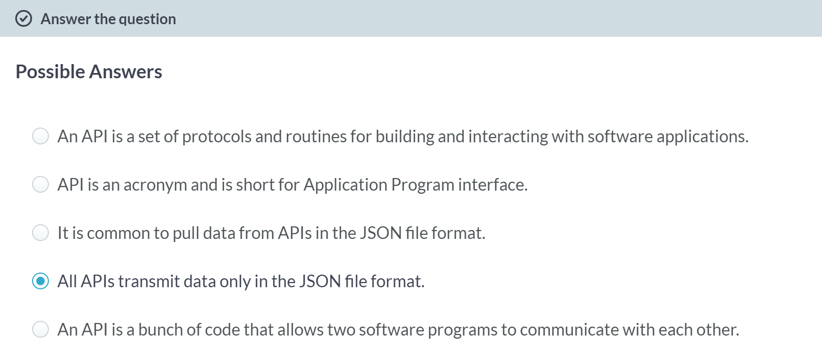

# API requests

Now it's your turn to pull some movie data down from the Open Movie Database (OMDB) using their API.

The movie you'll query the API about is The Social Network. Recall that, in the video, to query the API about the movie *Hackers, Hugo's query string* was 'http://www.omdbapi.com/?t=hackers' and had a single argument t=hackers.

Note: recently, OMDB has changed their API: you now also have to specify an API key. This means you'll have to add another argument to the URL: apikey=72bc447a.

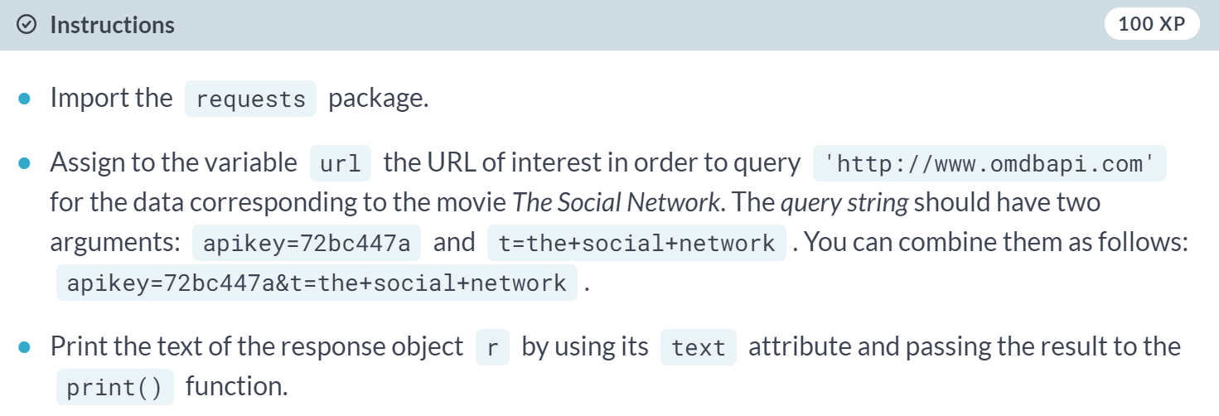  
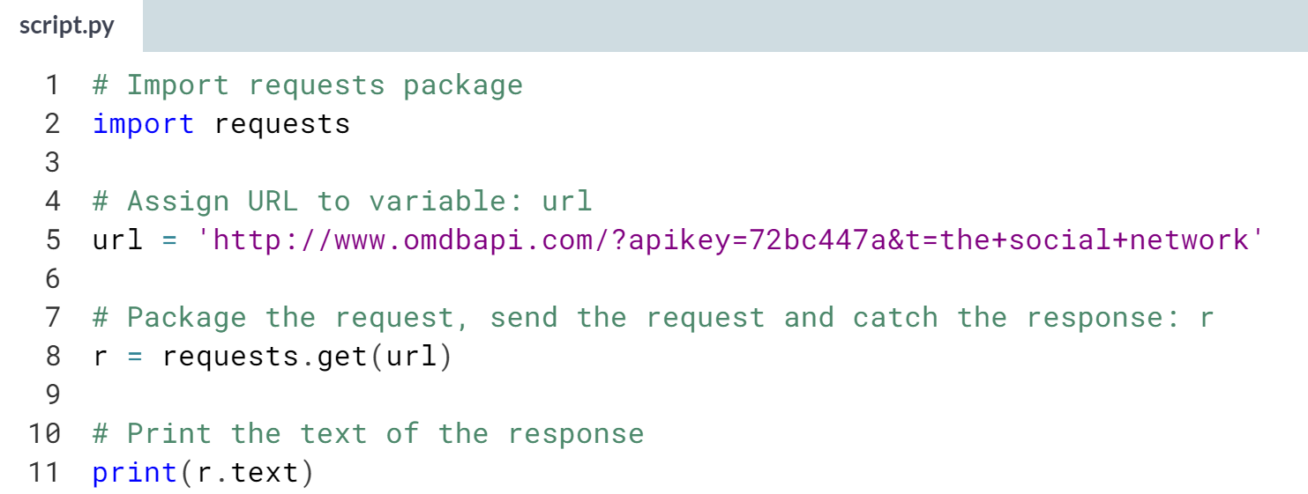  
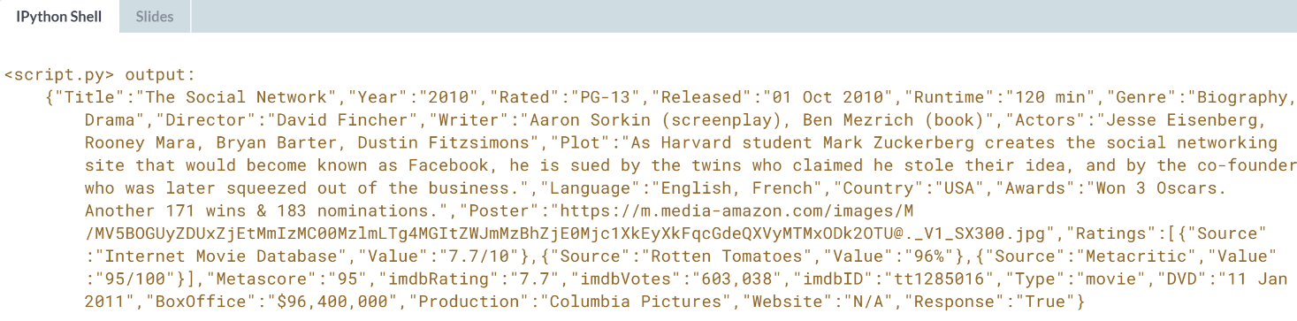

# JSON–from the web to Python

Wow, congrats! You've just queried your first API programmatically in Python and printed the text of the response to the shell. However, as you know, your response is actually a JSON, so you can do one step better and decode the JSON. You can then print the key-value pairs of the resulting dictionary. That's what you're going to do now!

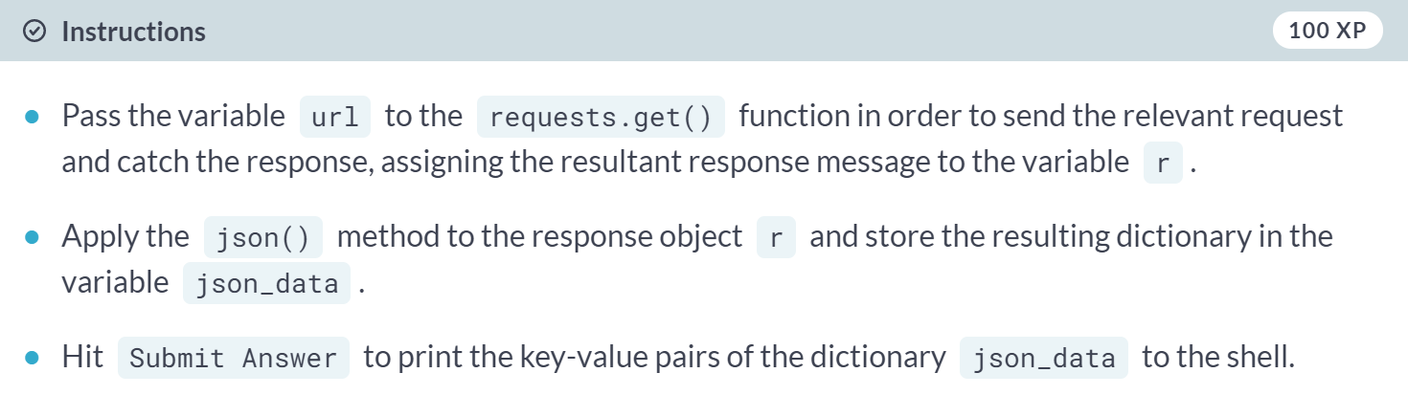

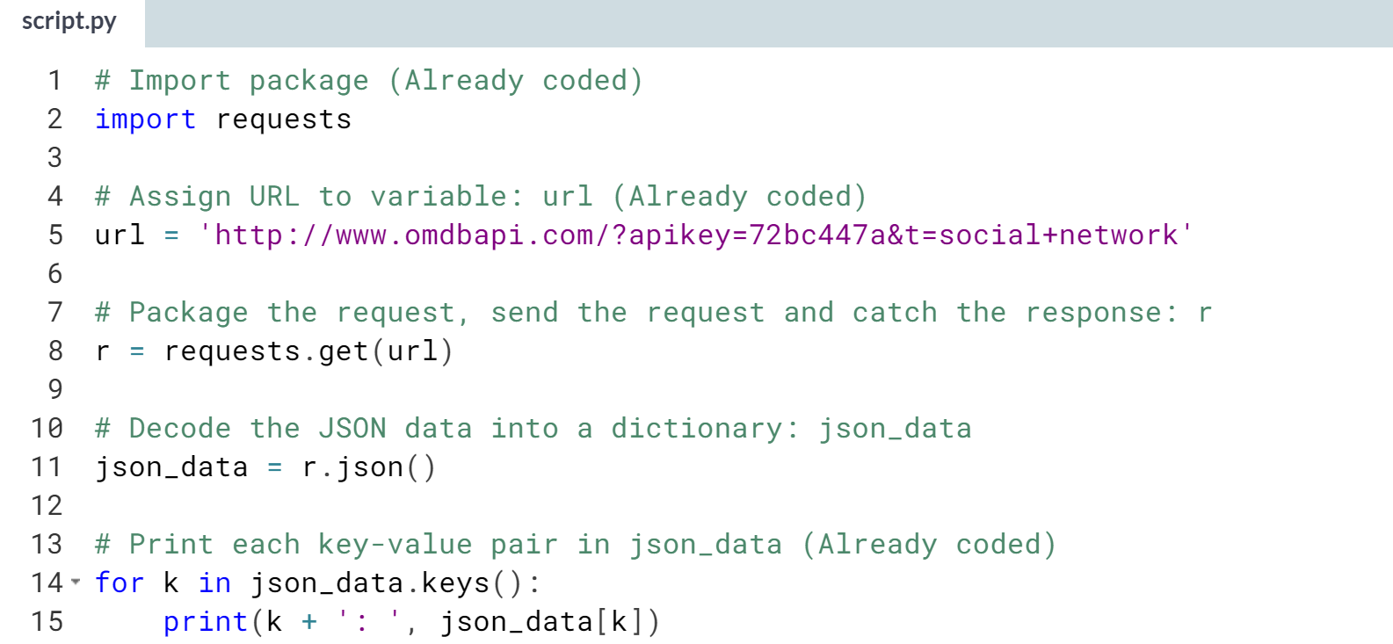

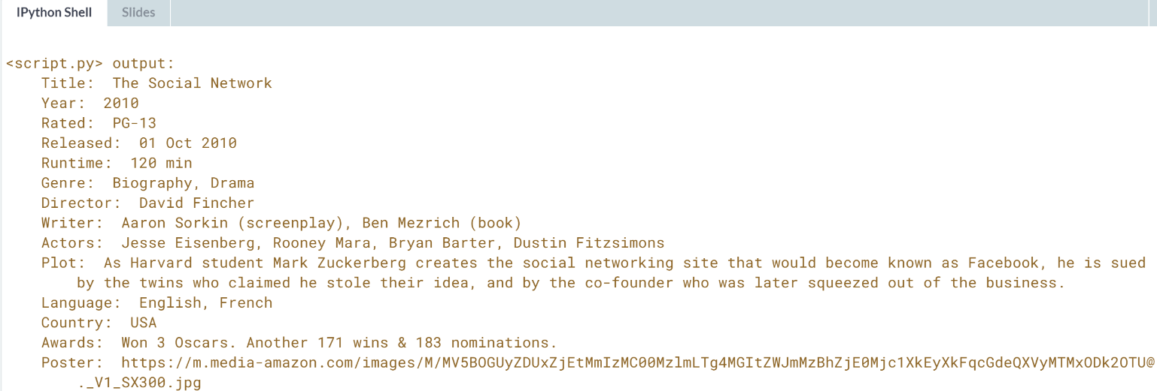

# Checking out the Wikipedia API

You're doing so well and having so much fun that we're going to throw one more API at you: the Wikipedia API (documented [**here**](https://www.mediawiki.org/wiki/API:Main_page)). You'll figure out how to find and extract information from the Wikipedia page for Pizza. What gets a bit wild here is that your query will return nested JSONs, that is, JSONs with JSONs, but Python can handle that because it will translate them into dictionaries within dictionaries.

The URL that requests the relevant query from the Wikipedia API is

https://en.wikipedia.org/w/api.php?action=query&prop=extracts&format=json&exintro=&titles=pizza

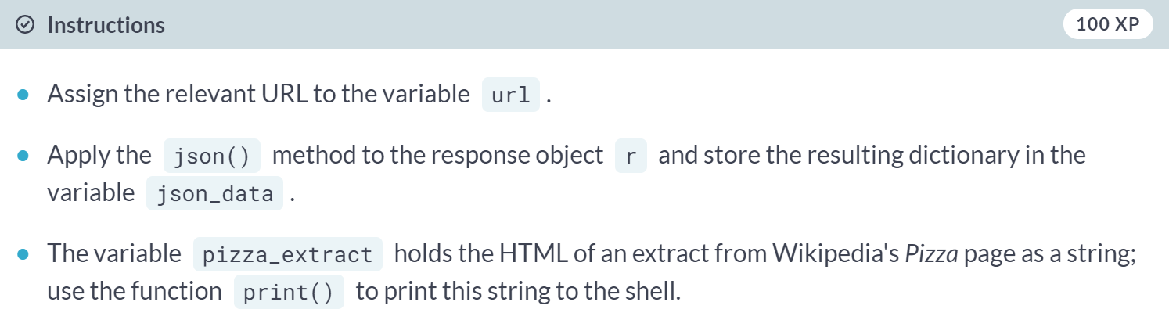  
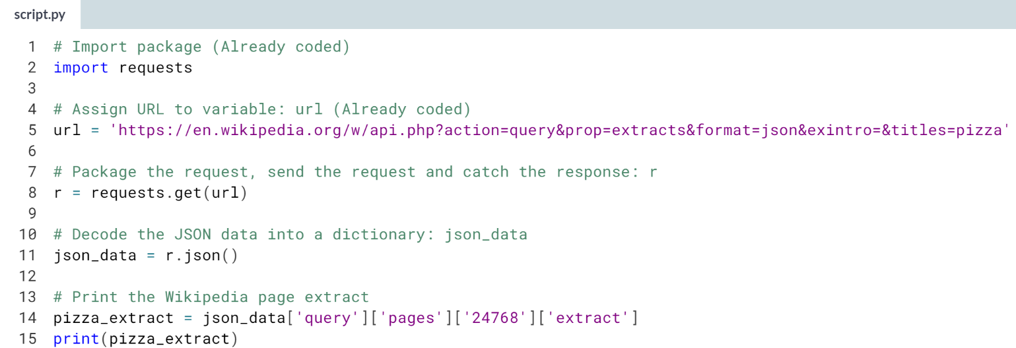  
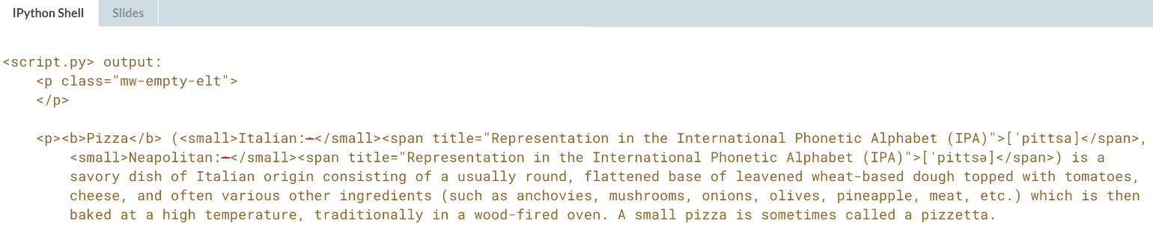

**3. Diving deep into the Twitter API**

In this chapter, you will consolidate your knowledge of interacting with APIs in a deep dive into the Twitter streaming API. You'll learn how to stream real-time Twitter data, and how to analyze and visualize it.



As a final deep dive, you are going to stream data from the Twitter API.

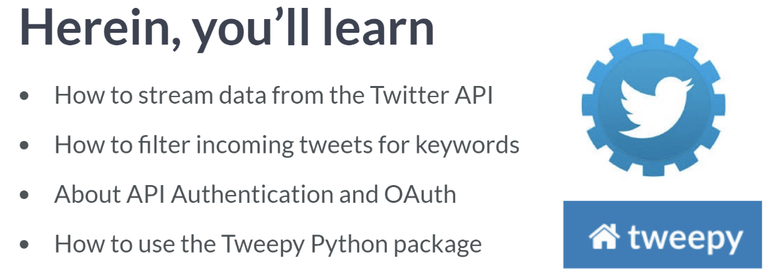

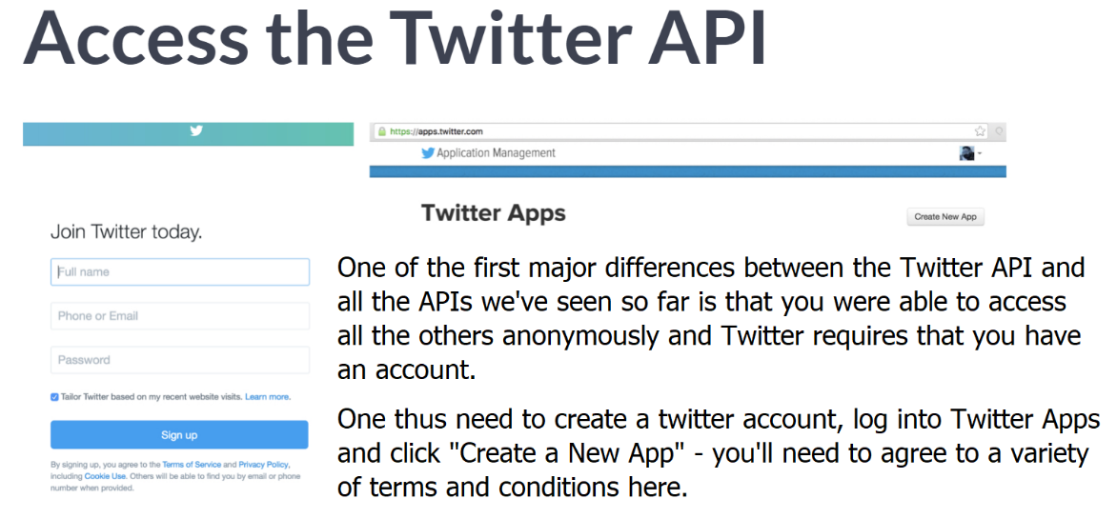

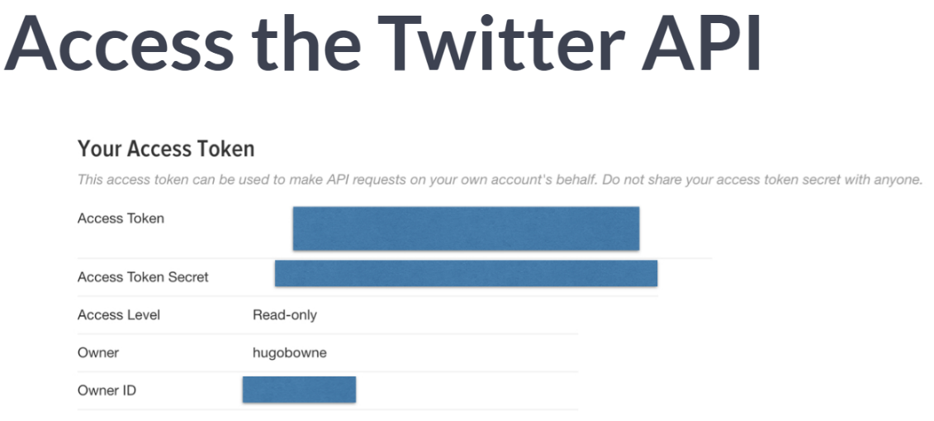  
Then, go to your "Keys and Access Tokens" tab and Copy your API key, your API secret, your Access Token and your Access Token secret. These are the Authentication credentials that will allow you to access the Twitter API from Python.

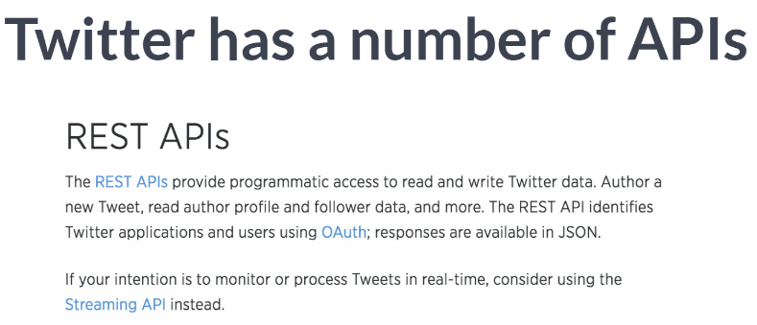  
REST API allows the user to "read and write Twitter Data"

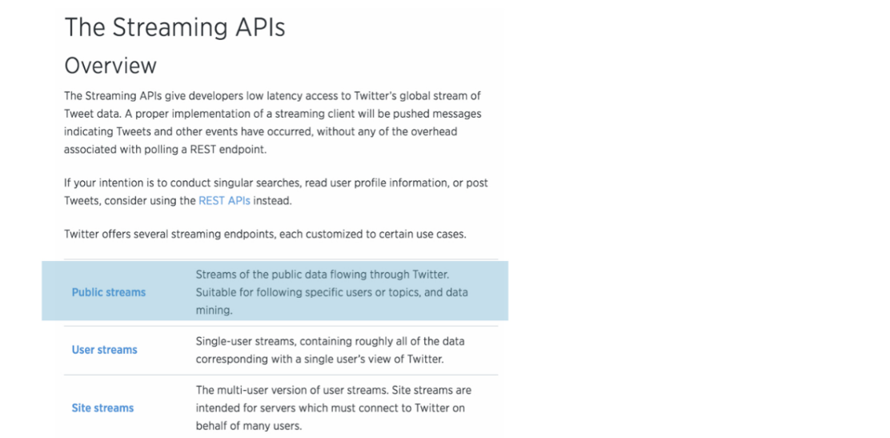  
To stream Twitter data in real time, we will want to use Twitter's Streaming API. In particular, we will use the public stream, which Twitter's API documentation states "Streams of the public data flowing through Twitter." The Public Stream itself contains a number of options.

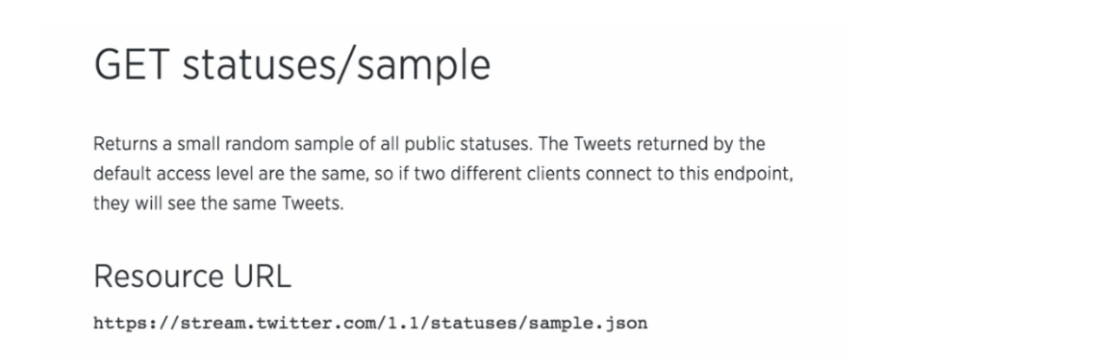  
As we want to read and process tweets, we will want to use GET statuses/sample API, which "Returns a small random sample of all public statuses."

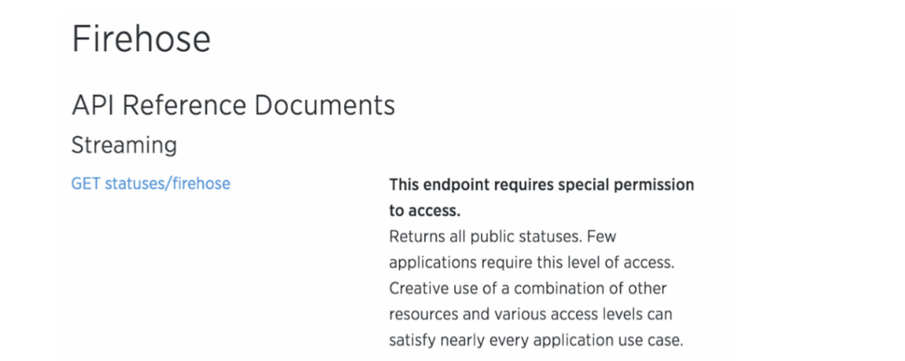  
If you wanted to access absolutely "All public statuses", you would need to use Twitter's Firehose API, which is not publicly available and would most likely cost you a pretty penny.

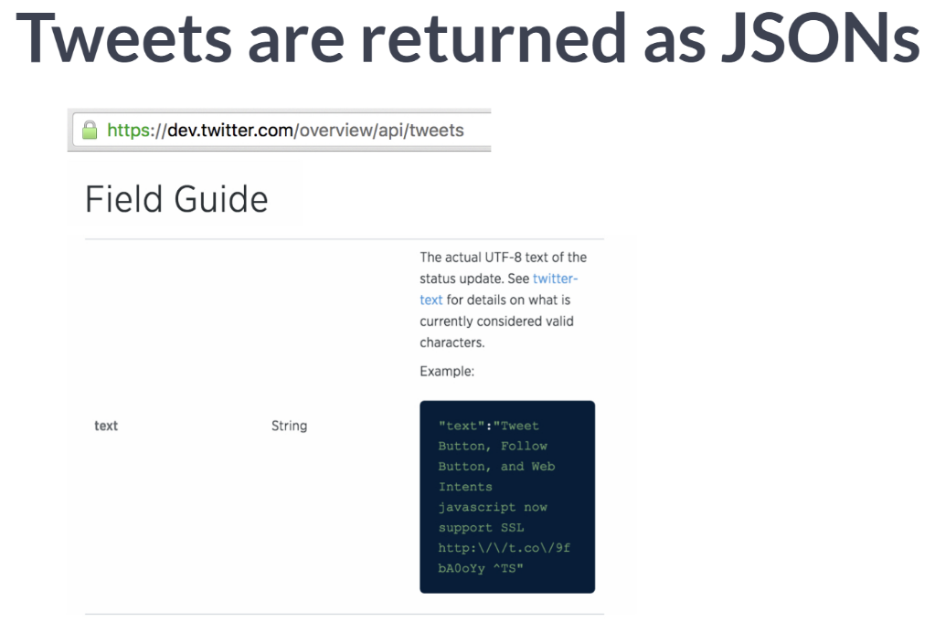  
tweets are returned to us as JSONs and they contain numerous possible fields. Check out the Twitter tweet field guide here. You can get tweet text, user, language, time of tweet, among many other field.

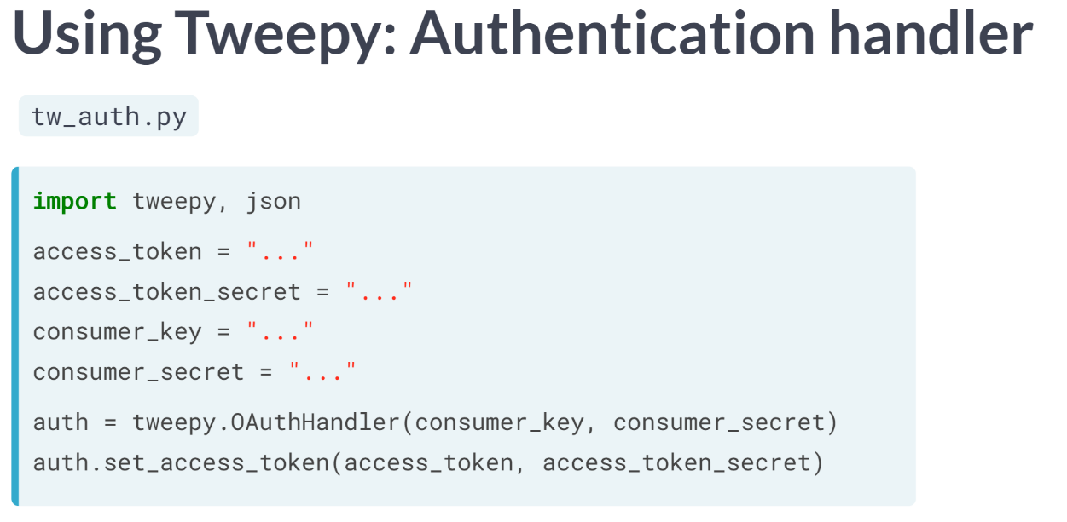  
Let's now see how to access and stream data from the Twitter API. For first time Python streamers, package *tweepy* is recommended, which has a nice balance of usability and capability.

Let's now use it to stream some tweets. First off, it has an ***OAuthHandler()***, which takes care of all of that nasty stuff for you: all you need to do is to pass the *API key* and *Secret* to the handler and then to pass to access credentials using the ***set_access_token()*** method.

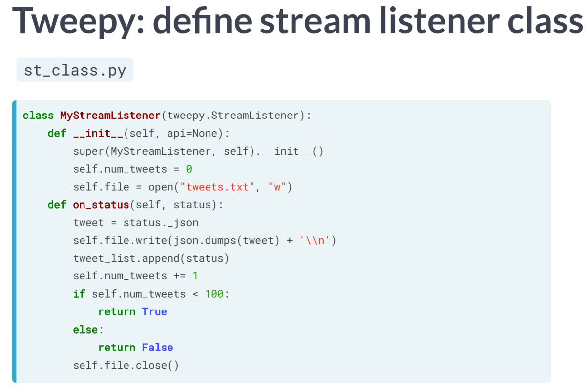  
After this, you will need to define your Twitter StreamListener class. Here, Tweet listener that creates a file called 'tweets.txt' is defined, collects streaming tweets and writes them to the file 'tweets.txt'. Once 100 tweets have been streamed, the listener closes the file and stops listening.

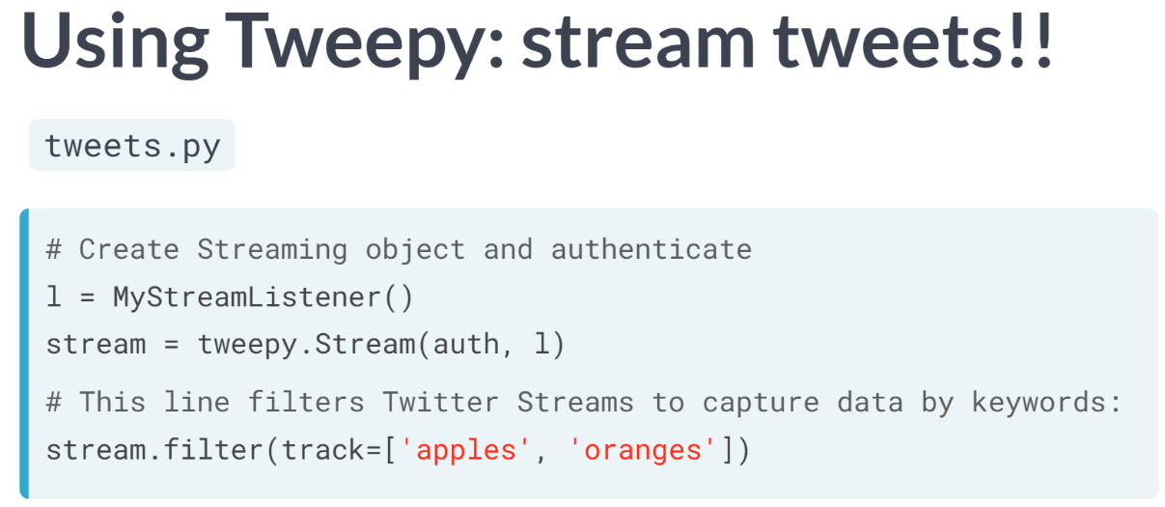  
Now that we have written our Twitter Stream Listener Class, all we need to do is create an instance of it and authenticate it. You can then stream tweets that containing keywords of choice by applying the filter method to the object stream. In the following exercises, you will practice writing Python code to stream tweets and then do some basic analysis of these tweets to see how often particular keywords are mentioned.

# API Authentication

The package tweepy is great at handling all the Twitter API OAuth Authentication details for you. All you need to do is pass it your authentication credentials.

In this interactive exercise, we have created some mock authentication credentials (if you wanted to replicate this at home, you would need to create a [**Twitter App**](https://apps.twitter.com/) as Hugo detailed in the video). Your task is to pass these credentials to tweepy's OAuth handler.

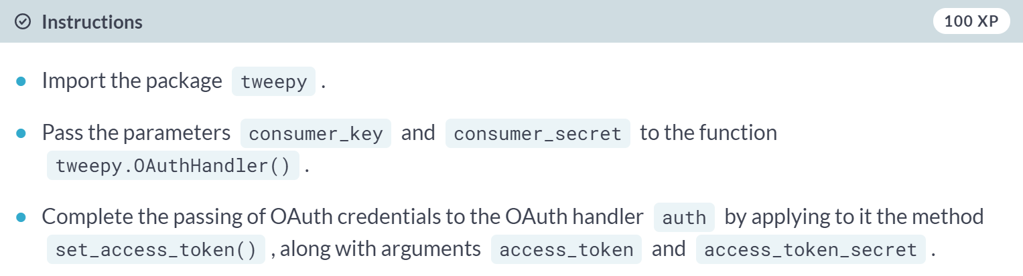

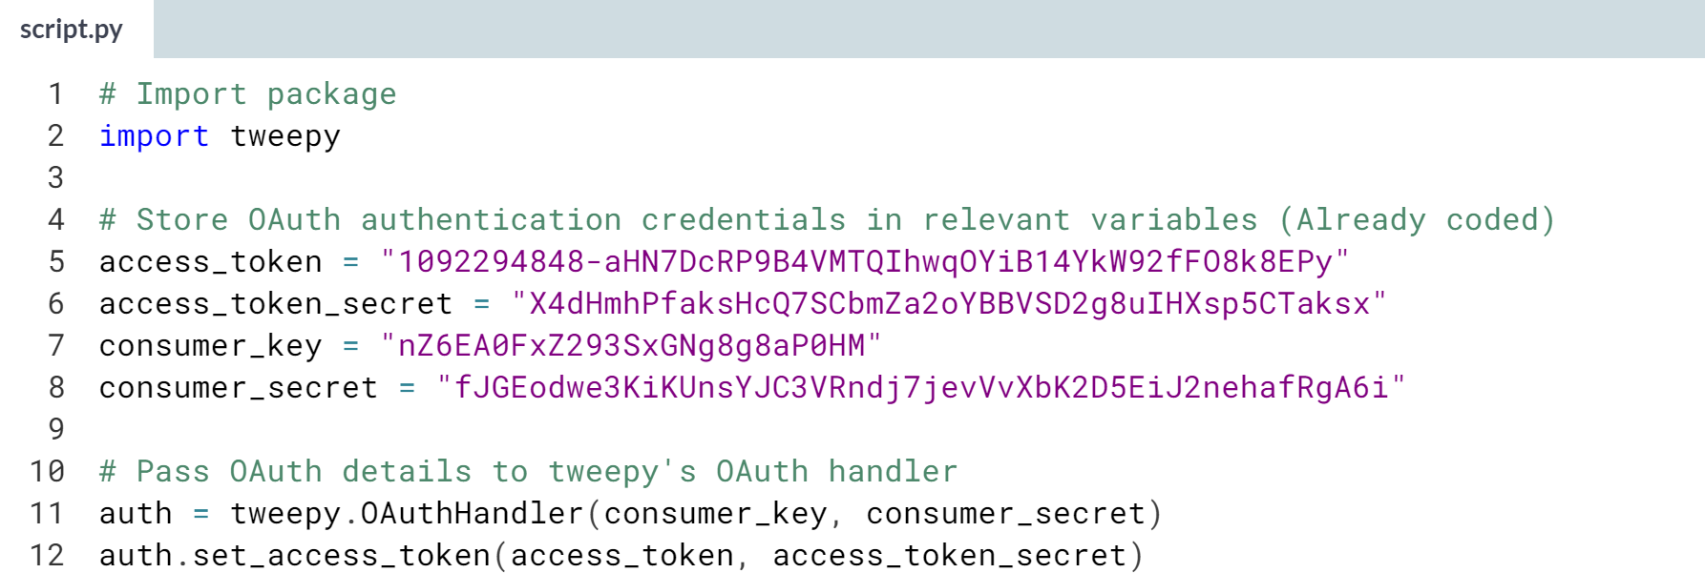

# Streaming tweets

Now that you have set up your authentication credentials, it is time to stream some tweets! We have already defined the tweet stream listener class, MyStreamListener, just as Hugo did in the introductory video. You can find the code for the tweet stream listener class [**here**](https://gist.github.com/hugobowne/18f1c0c0709ed1a52dc5bcd462ac69f4).

Your task is to create the Stream object and to filter tweets according to particular keywords.

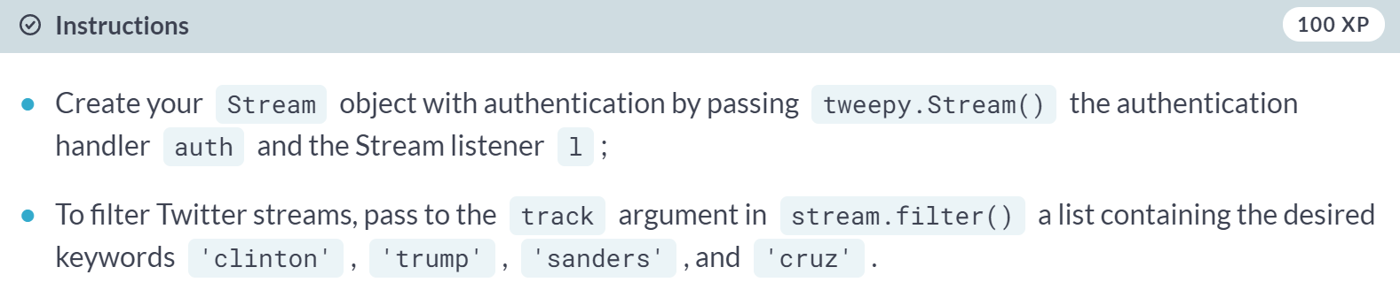

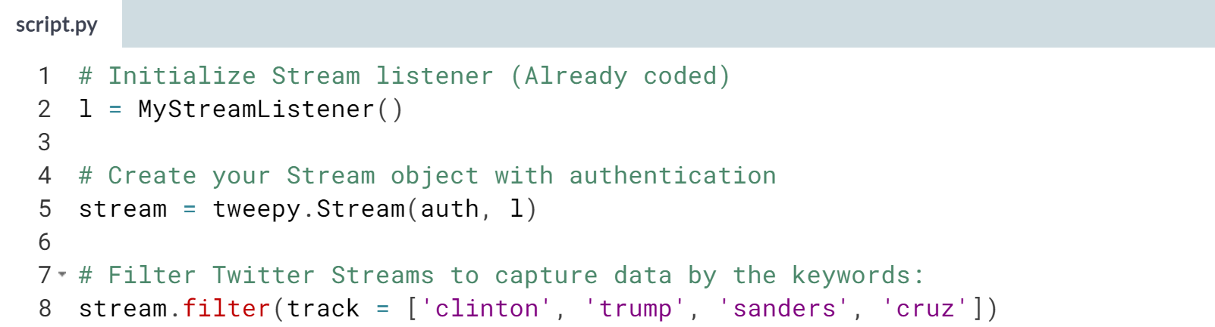

# Load and explore your Twitter data

Now that you've got your Twitter data sitting locally in a text file, it's time to explore it! This is what you'll do in the next few interactive exercises. In this exercise, you'll read the Twitter data into a list: tweets_data.

Be aware that this is real data from Twitter and as such there is always a risk that it may contain profanity or other offensive content (in this exercise, and any following exercises that also use real Twitter data).

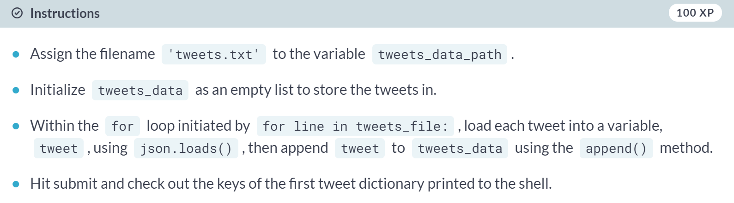  
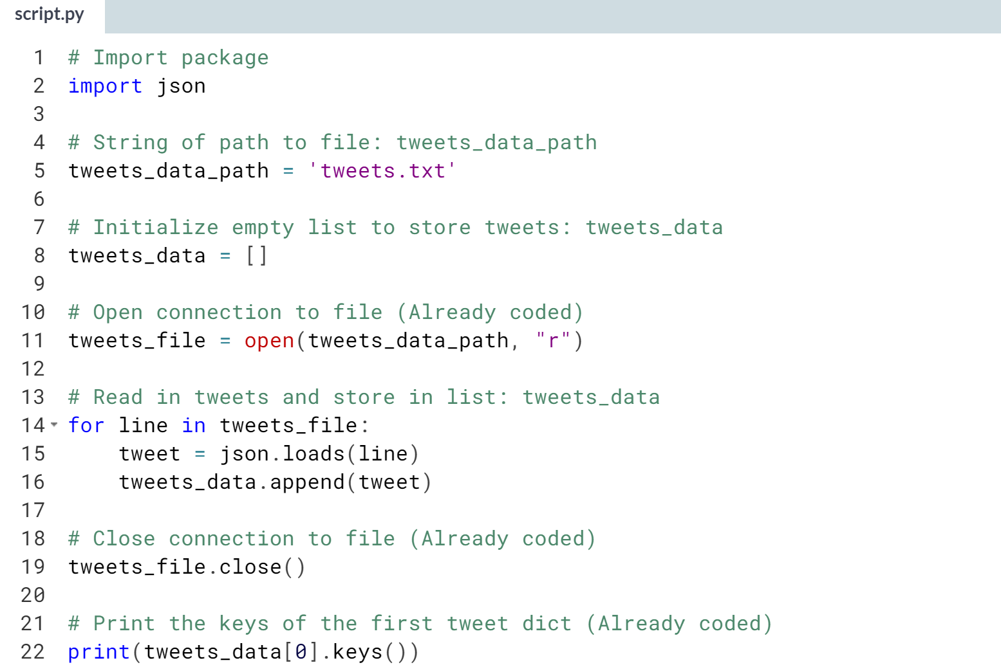

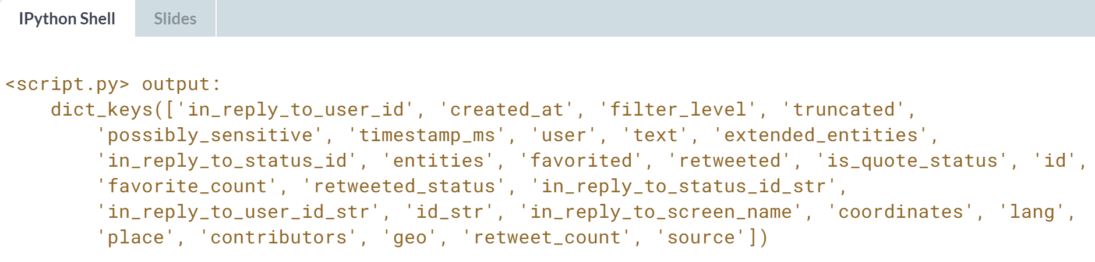

# Twitter data to DataFrame

Now you have the Twitter data in a list of dictionaries, tweets_data, where each dictionary corresponds to a single tweet. Next, you're going to extract the text and language of each tweet. The text in a tweet, t1, is stored as the value t1['text']; similarly, the language is stored in t1['lang']. Your task is to build a DataFrame in which each row is a tweet and the columns are 'text' and 'lang'.

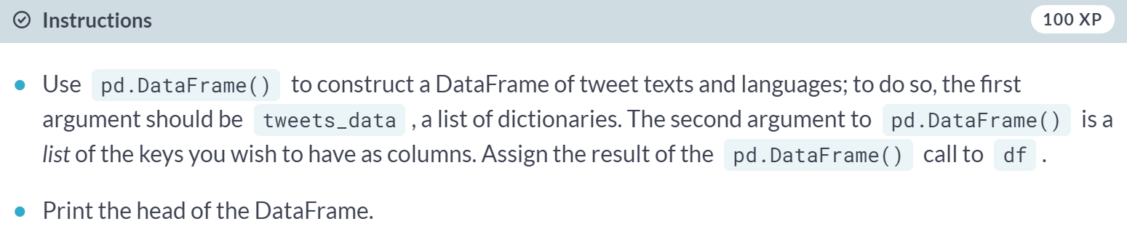

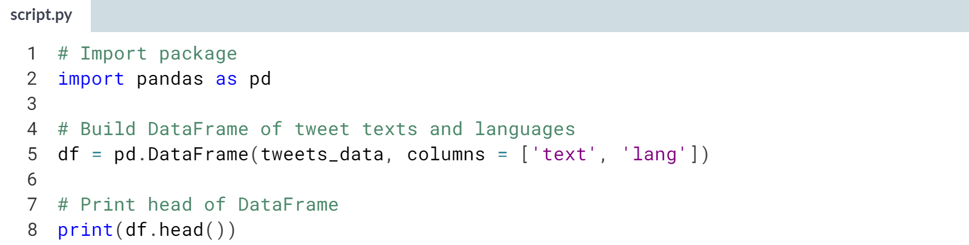

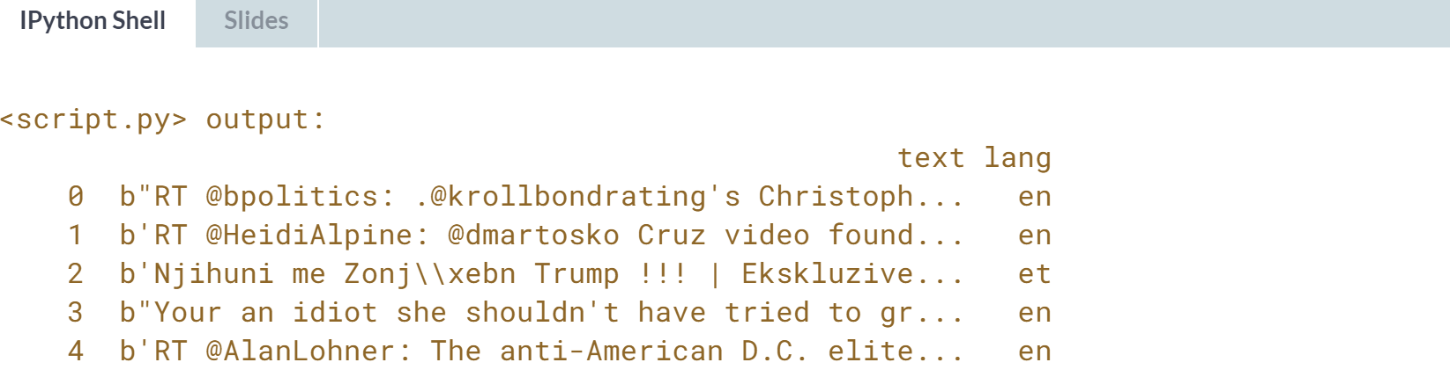

# A little bit of Twitter text analysis

Now that you have your DataFrame of tweets set up, you're going to do a bit of text analysis to count how many tweets contain the words 'clinton', 'trump', 'sanders' and 'cruz'. In the pre-exercise code, we have defined the following function word_in_text(), which will tell you whether the first argument (a word) occurs within the 2nd argument (a tweet).

import re

def word_in_text(word, text):

word = word.lower()

text = text.lower()

match = re.search(word, text)

if match:

return True

return False

You're going to iterate over the rows of the DataFrame and calculate how many tweets contain each of our keywords! The list of objects for each candidate has been initialized to 0.

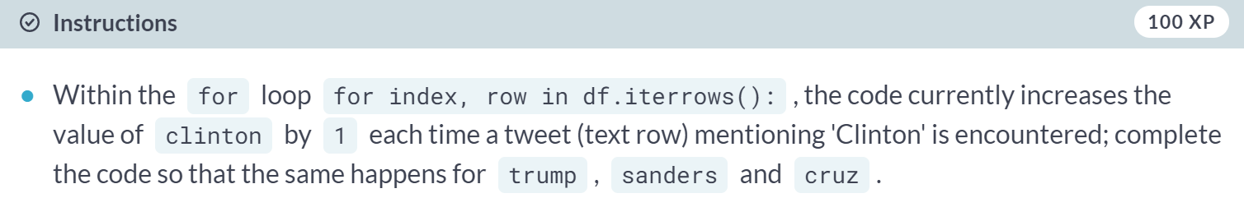

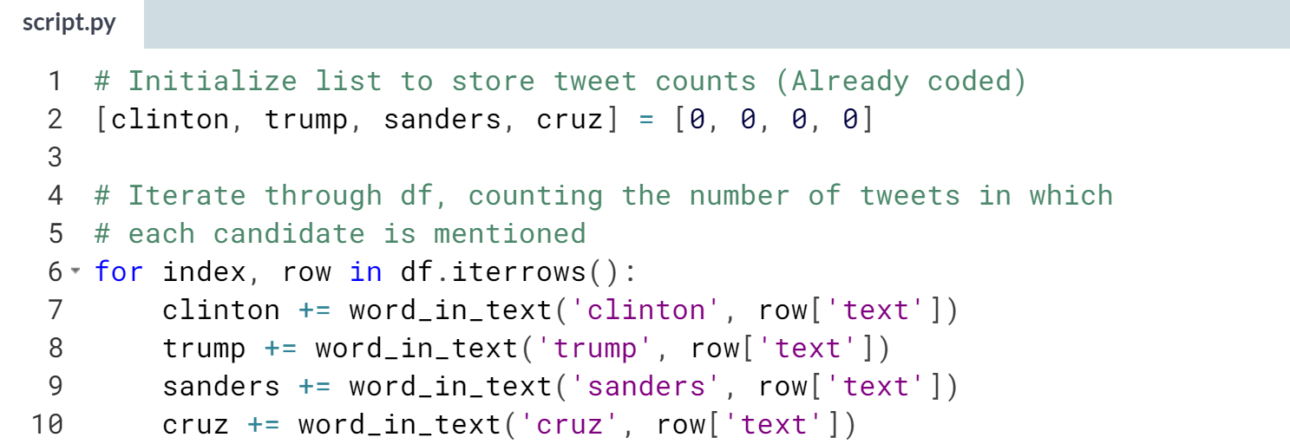

# Plotting your Twitter data

Now that you have the number of tweets that each candidate was mentioned in, you can plot a bar chart of this data. You'll use the statistical data visualization library [**seaborn**](https://stanford.edu/~mwaskom/software/seaborn/), which you may not have seen before, but we'll guide you through. You'll first import seaborn as sns. You'll then construct a barplot of the data using sns.barplot, passing it two arguments:

1. a list of labels and
2. a list containing the variables you wish to plot (clinton, trump and so on.)

Hopefully, you'll see that Trump was unreasonably represented! We have already run the previous exercise solutions in your environment.

